**Computing Research Project**

**Topic – Digital Transformation Strategies (DX)**

**Theme – E-commerce**

|  |  |
| --- | --- |
| **Name:** | **Darren Farrell** |
| **Code:** | **BDSE** |



**Lithan EduClaas  
2023**

# ABSTRACT

This research project is centered around the creation of a cutting-edge e-commerce website for Jumpstart, a distinguished retail chain boasting 750 stores nationwide. The project's primary objective is to reshape Jumpstart's business model to thrive in the post-COVID-19 business landscape by harnessing the power of digital commerce. Our approach leverages modern technologies and tools, including VS Code, Google Chrome, Postman API, MySQL DB, and a versatile array of programming languages, such as HTML, CSS, JavaScript, and Java. These resources will be pivotal in the development of an innovative, responsive, and user-friendly e-commerce platform. The website's core features are designed to enhance customer experiences, reduce cost and increase operational efficiency. These features include a cart system, checkout page to checkout multiple items together, and a fully automated payment getaway system. Together, they aim to provide Jumpstart with the tools to cater to a broad customer base while optimizing internal processes. Within the scope of this research project, we meticulously detail critical components, including a comprehensive testing plan, risk assessment, budget allocation, strategic milestones, and a roadmap outlining the project's stages. The project anticipates delivering improved operational efficiency, increased revenue streams, and enhanced customer engagement. Furthermore, it is aimed at establishing Jumpstart as a prominent player in the modern retail landscape.

**RESEARCH PART (PART I)**

1. Introduction
   1. Research Background

E-commerce has become a pivotal force in the retail sector, fundamentally altering how businesses interact with customers and the marketplace. In the wake of emerging technologies and shifting consumer behaviors, the retail landscape has evolved, presenting new challenges and opportunities. This transformation has only been accelerated by the global disruption caused by the COVID-19 pandemic.

In response to these formidable challenges, Jumpstart, a prominent retail chain with 750 stores nationwide, is embarking on a visionary journey to reshape its business model. The objective is to pivot toward customer-centric commerce, harnessing the vast potential of e-commerce to thrive in the evolving post-COVID-19 business environment.

To achieve this transformation, Jumpstart has partnered with Aceadora Tech, a leading enterprise solution provider, to embark on a mission to develop a dynamic e-commerce website. This website represents not just a digital storefront, but a gateway to unparalleled customer experiences and operational efficiency.

The project recognizes the necessity of a robust and efficient e-commerce platform that can adapt to the rapidly changing business landscape. It seeks to enhance customer experiences, reduce cost and increase operational efficiency.

At its core, this research project is dedicated to crafting an e-commerce platform that caters to the evolving needs of the retail industry. It necessitates extensive research into the finest E-commerce practices and the latest technologies and frameworks suitable for constructing a dependable system. The ultimate aspiration is to deliver to Jumpstart a scalable, user-friendly, and cost-effective e-commerce solution. One that empowers them to streamline operations, elevate the customer experience, and secure a competitive edge in a digital-first world.

* 1. Research Purpose

The purpose of this research is to conduct a comprehensive examination and analysis of Jumpstart's current e-commerce practices. Jumpstart, a prominent retail chain with a presence spanning 750 stores nationwide, faces the challenge of adapting to the new post-COVID-19 business environment and reshaping its business model towards customer-centric commerce.

The core objective of this research is to identify areas within Jumpstart's e-commerce operations that hold potential for improvement. Rather than merely highlighting these areas, the research aims to provide actionable recommendations and solutions.

The goal is to equip Jumpstart with strategies and insights that enable them to navigate the complexities of the contemporary remote working landscape. This research project is a proactive endeavor to enhance Jumpstart's e-commerce capabilities, ensuring that they remain competitive and customer-focused in a rapidly evolving digital commerce landscape.

1. Literature Review

10 to 12 papers (publications) you need to summarize after deeply reviewing them along with its title and authors list and publication year.

* The change in e-commerce in the context of the Coronavirus pandemic

Author: Dorel Mihai PARASCHIV

Publication: 2020  
Summary:

The document delves into the utilization of e-commerce and online shopping across various nations, shedding light on shifts in online activities during the COVID-19 pandemic. It notes that the Netherlands and Finland exhibit the highest proportions of individuals engaged in online selling, while Denmark and Sweden boast the highest percentages of people making online purchases. Belgium and Ireland emerge as leaders in terms of enterprises' turnover attributed to e-commerce.

The document further explores different groupings of countries based on their e-commerce performance, placing Slovenia, Poland, and Hungary as the most prominent representatives in the middle cluster. In contrast, Bulgaria, Romania, and Italy appear in the lower-performing cluster, with Italy showing distinct characteristics within this group.

Overall, the year 2020 witnessed a surge in e-commerce compared to 2019 across the European Union, with notable spikes observed in Hungary, Romania, and Cyprus. However, it's crucial to acknowledge that the analysis possesses certain limitations due to its reliance on a limited set of indicators.

* The Impact of COVID-19 Pandemic on E-commerce

Author: Jin Gao, Xindi Yu, Yuou Wang

Publication: 2020

Summary:

Covid19 had a positive impact on the e-commerce industry, with the online shopping division experiencing the greatest impact. The overall impact of the pandemic on e-commerce was positive, and there is potential for further innovation in this area. Increasing demand for online shopping.

* E-commerce trends during COVID-19 Pandemic

Author: Anam Bhatti, Hamza Akram, Hafiz Muhammad Basit, Ahmed Usman Khan, Syeda Mahwish Raza Naqvi, Muhammad Bilal

Publication: 2020

Summary:

The document discusses the impact of the COVID-19 pandemic on e-commerce trends. It highlights how the pandemic has changed consumer behavior, increased the growth of e-commerce, and affected economies worldwide. Specific examples are given, such as the increase in online shopping and the rise of e-commerce in developing countries like Pakistan. The document also mentions the need for further research in this area.

* COVID-19 IMPACT ON E-COMMERCE USAGE: AN EMPIRICAL

EVIDENCE FROM MALAYSIAN HEALTHCARE INDUSTRY

Author: Arfan Shahzad, Rohail Hassan, Nor Izani Abdullah, Arsalan Hussain, Muhammad Fareed

Publication: 2020

Summary:

The positive impact of IT infrastructure, external pressure, and supply chain integration on e-commerce usage has been found in the study. This has implications for various stakeholders in the healthcare industry, including government, hospital management, doctors, academic researchers, and entrepreneurs. The implementation of e-commerce in healthcare can enhance the quality of services, improve business performance and operations, and contribute to the adoption of new technology in the industry. It is seen as an essential part of the process to improve efficiency and achieve targets, especially in the post-COVID-19 era.

* The Effect of COVID-19 Spread on the e-commerce market:

The case of the 5 largest e-commerce companies in the world

Author: Mansour Abd Elrhim, Abdullah Elsayed

Publication: 2020

Summary:

The COVID-19 pandemic has driven consumers towards online shopping, affecting demand and supply chain issues in the e-commerce industry. It has also impacted traditional retailers like Walmart, leading to a decline in in-person shopping and disruptions in supply chains. E-commerce, involving online transactions and the exchange of value for products or services, is gaining importance in the wake of the pandemic. The World Trade Organization emphasizes the significance of e-commerce in supporting the global economy.

1. Research Plan
   1. Research:

Research constitutes a systematic and methodical exploration, a quest to unravel specific subjects or quandaries. Employing a diverse array of methods and techniques, research hinges on the collection and scrutiny of data, seeking to either furnish fresh insights or corroborate existing knowledge. Its essence lies in broadening our comprehension of a particular sphere or phenomenon, contributing to the evolution of theories, concepts, or practical applications. Research spans a multitude of domains, spanning from the sciences, social sciences, and humanities to engineering and medicine, among others.

* 1. Research Philosophy (**Saunders’s Onion theory):**

Saunders's Onion Theory is a layered framework for understanding research philosophy, offering clarity on a researcher's ontological and epistemological stance. In the context of the E-commerce research for Jumpstart, the ontological stance centers on the belief in an objective reality of E-commerce. The epistemological position asserts that this reality is accessible through empirical observation and theoretical analysis.

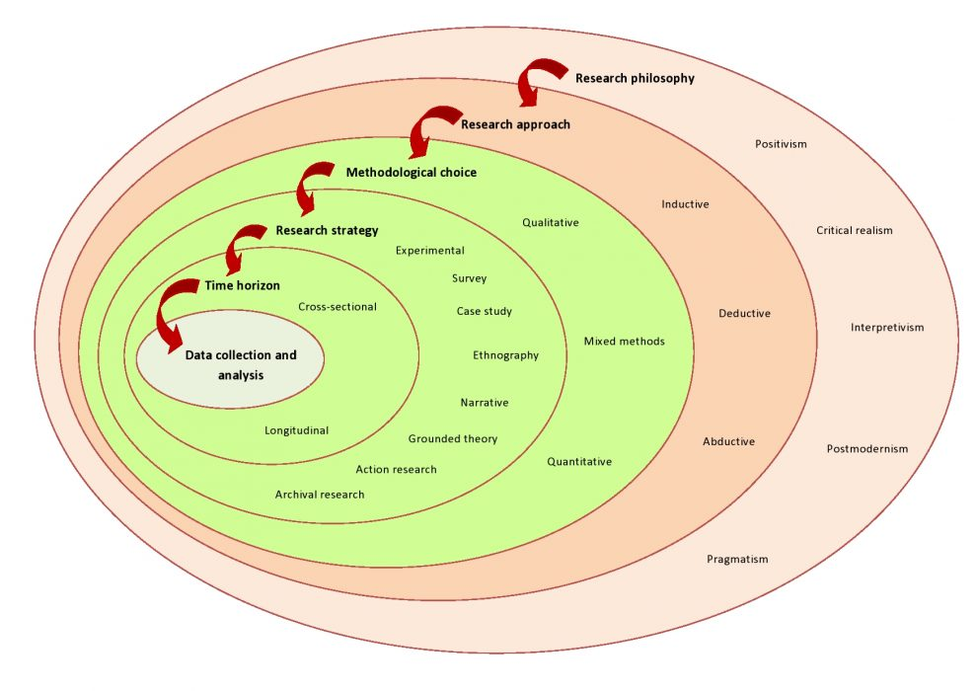

At the core of the onion theory lies the research paradigm, adopting the positivist paradigm for this endeavor. This paradigm asserts the existence of an objective reality, amenable to observation and measurement, and advocates for value-neutral, bias-free research.

The subsequent layer encompasses the research design, amalgamating quantitative and qualitative methodologies. Quantitative data comes into play for measuring inventory metrics, while qualitative data delves into the experiences and perspectives of Jumpstart's staff and clientele.

Moving on, the research strategy adopts a case study approach, homing in on Jumpstart as a singular case. It aims to glean intricate insights into the E-commerce practices and challenges peculiar to this company.

The temporal dimension, the next layer, opts for a cross-sectional approach. This research snapshot captures the prevailing E-commerce scenario at Jumpstart during a specific juncture.

Lastly, the techniques of data collection and analysis feature surveys, interviews, and data analysis software, constituting the toolkit. A synthesis of these methods ascertains comprehensive comprehension of Jumpstart's E-commerce practices and identifies avenues for enhancement.

* 1. Gantt Chart and Work Breakdown Structures (WBS) for Research Proposal

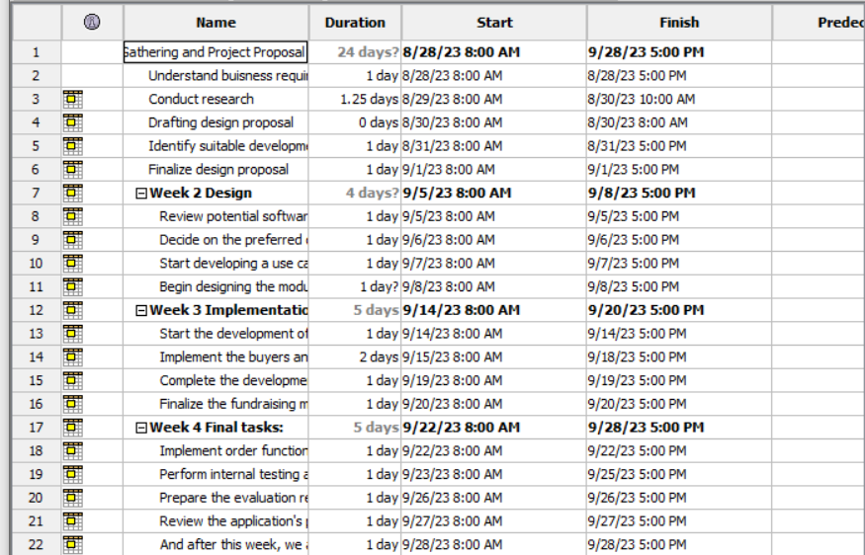

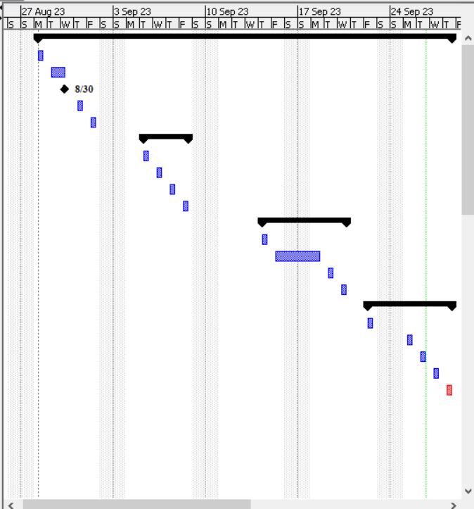

WBS

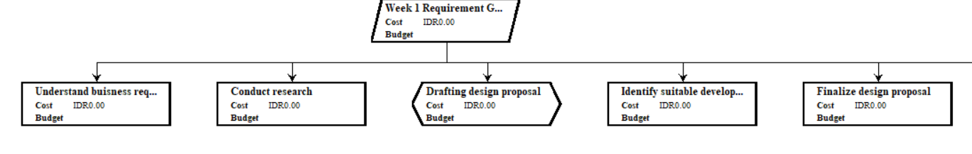

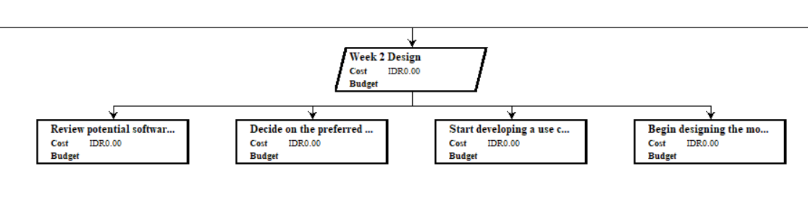

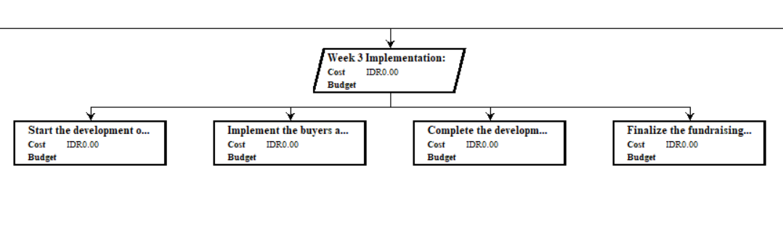

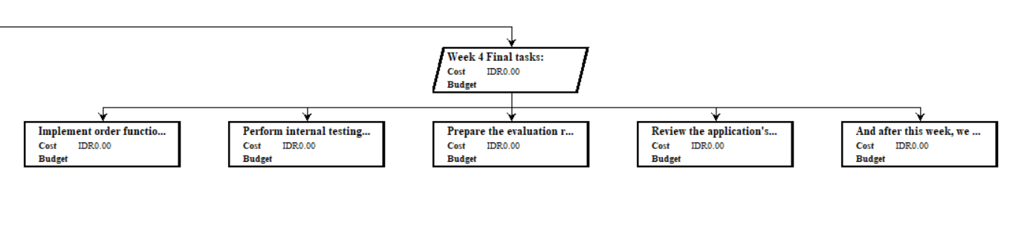

1. Research Methodologies – Refer Green Color in the detailed guides below
   1. Primary Research – Define with example

Primary research constitutes the method of directly acquiring original data from its source, distinct from relying on pre-existing, publicly available data. In this research form, the investigator or their team actively engages in data collection tailored explicitly to their research queries.

* + 1. Primary Research Methodologies

Surveys: Surveys manifest as structured questionnaires designed to collect data from a diverse pool of participants. These surveys may be executed through various avenues, including face-to-face interviews, phone-based interactions, mail-in questionnaires, or digital platforms. They encompass both tightly structured questions and open-ended inquiries, yielding a rich mix of quantitative and qualitative insights.

Interviews: Interviews involve engaging with carefully selected individuals to delve deeply into their experiences, perspectives, attitudes, and behaviors. These interactions can occur through in-person meetings, telephone conversations, or virtual exchanges.

Observations: Observations entail the systematic recording of data through the act of observing and documenting behaviors or events. This can transpire in natural, uncontrolled settings or within controlled environments. Observation techniques encompass both highly structured and more flexible, open-ended approaches.

Focus Groups: Focus groups assemble a specific cohort of participants to engage in discussions centered around a particular theme or issue. These gatherings, typically guided by a skilled moderator, aim to unearth qualitative insights into participant attitudes, opinions, and behaviors.

These primary research methodologies serve as the vehicle for generating freshly harvested data. This data is precisely honed to address specific research questions, explore targeted subjects, or rigorously test hypotheses, thereby contributing to the depth of research inquiry.

* + 1. Merits/Demerits/Pitfalls for each method

|  |  |  |  |
| --- | --- | --- | --- |
| **No** | **Methodology** | **Merits** | **Demerits** |
| 1 | Survey | • Swift data collection from diverse participants.  • Can be conducted in-person or remotely.  • Structured responses enable uniformity.  • Allows statistical analysis to uncover patterns and trends. | • Vulnerable to response bias and potential reporting inaccuracies.  • May not fully capture the complexity of participants' thoughts and experiences.  • Low response rates may hinder representativeness. |
| 2 | Interview | • Enables in-depth exploration of participants' ideas, experiences, and perspectives.  • Can adapt to participants' comfort and communication styles.  • Immediate clarification and questioning of responses.  • May yield unexpected insights or findings. | • Potentially time and resource-intensive.  • Susceptible to social desirability bias and response bias.  • Prone to interviewer's personal biases or beliefs.  • Risk of miscommunication or misunderstandings. |
| 3 | Observation | • Allows the collection of data on natural phenomena or behaviors.  • Objectively records information without reliance on self-reporting.  • Provides insights into the context and setting of specific behaviors or activities. | • Subject to observer bias or misinterpretation.  • May not fully encompass the range of experiences or motivations behind a behavior.  • Ethical or practical constraints may hinder observation of certain behaviors or environments. |
| 4 | Focus Group | • Explores group dynamics and shared experiences.  • Yields rich qualitative data on attitudes, beliefs, and experiences.  • Fosters a sense of belonging and understanding among participants. | • Dominant or vocal participants can influence group outcomes.  • May not fully represent the diversity of experiences or perspectives within the group.  • Susceptible to conformity bias or groupthink.  • Complex group interactions can pose challenges during analysis. |

* 1. Secondary Research

Secondary research involves reviewing existing data, information, and research conducted by other people in the industry. This data is sourced from various outlets like academic journals, reports, and publications.

* + 1. Sources of data

Internal Sources:

These originate from within the organization itself and encompass data like financial reports, sales records, customer databases, inventory data, and other information routinely gathered and processed as part of the organization's day-to-day functions.

External Sources:

These originate from outside the organization and include materials such as published reports, industry studies, government publications, census reports, trade journals, newspapers, and other sources providing information pertinent to the organization's research requisites.

* + 1. Secondary Research Methodologies

Secondary research methodologies involve collecting data from published sources from other people to do research about the industry, some of secondary research methodology are:

Literature Reviews: An examination of existing literature related to a specific research question or topic.

Meta-Analysis: A statistical method that combines findings from multiple studies to estimate overall effects.

Systematic Reviews: A methodical approach to reviewing literature with strict guidelines for objectivity and reproducibility.

Content Analysis: Analyzing written, auditory, or visual content to identify patterns and recurring themes.

* + 1. Merits/Demerits/Pitfalls for each method

|  |  |  |  |
| --- | --- | --- | --- |
| **No** | **Methodology** | **Merits** | **Demerits** |
| 1 | Literature Review | - Provides an in-depth understanding of existing research on a specific topic or issue.  - Helps identify gaps or contradictions in the literature.  - Can inspire new research questions and theories.  - Cost-effective and efficient. | - Vulnerable to publication bias, where only studies with significant findings are published.  - Limited by the quality and relevance of available literature.  - May rely on outdated or inaccurate data.  - May not fully encompass the diversity of perspectives on the subject. |
| 2 | Meta-analysis | - Offers a statistical overview of existing research on a particular topic or problem.  - Detects relationships and patterns across multiple studies.  - Provides a more precise estimation of the impact of a variable or intervention.  - Allows testing of hypotheses not originally examined in the primary studies. | - Constrained by the quantity and quality of available studies for analysis.  - Influenced by publication bias or other biases in the selection of studies.  - Affected by variations in study populations and designs.  - Heterogeneity among included studies can be a limitation. |
| 3 | Systematic Review | - Offers a systematic and organized approach to reviewing and synthesizing existing research.  - Identifies gaps and inconsistencies in the literature.  - Provides a comprehensive understanding of the body of evidence related to a specific intervention or phenomenon.  - Useful for developing evidence-based recommendations. | - Time- and resource-intensive.  - Dependent on the quantity and quality of available studies.  - Susceptible to publication bias or other biases in study selection.  - Heterogeneity among studies can pose challenges. |
| 4 | Content Analysis | - Provides a structured and unbiased method for analyzing large volumes of data.  - Applicable to uncovering themes and patterns in written or visual content.  - Useful for exploring expressed attitudes, beliefs, and values.  - Can generate new theories or inquiries. | - Limited by the quality and applicability of the available data.  - Subject to the researcher's interpretation of the data.  - Challenged by the complexity of coding or categorizing intricate data.  - May not fully capture the diversity of perspectives on the subject. |

1. Research Approaches
   1. Qualitative Research

Qualitative research represents a research approach focused on exploring and comprehending individuals' perceptions, experiences, and viewpoints through the analysis of non-numerical data. It aims to delve deeply into human behavior, attitudes, and motivations. This methodology frequently involves the utilization of open-ended inquiries, interviews, focus groups, observations, and content analysis.

* + 1. Methodologies in Qualitative Research

Interviews:

An approach to gathering information that entails private discussions between the researcher and participants. Interviews can transpire in person, over the phone, or online, and they may adopt structured, semi-structured, or unstructured formats.

Focus Groups:

A method for acquiring information involving a researcher and a small group of participants engaging in group discussions. Focus groups are commonly employed to explore participant attitudes and experiences concerning specific topics.

Observation:

A technique for data collection that encompasses the observation and documentation of participant actions and interactions in their natural settings. This method allows for both structured and unstructured observations, with the researcher optionally participating.

Content Analysis:

The process of identifying patterns, themes, and meanings within textual or visual data, such as transcripts, documents, or images.

Case Study:

A technique for gathering information through extensive and ongoing investigations of a particular case or phenomenon. Case studies employ multiple data collection techniques, including interviews, observations, and document analysis.

* + 1. Merits/Demerits of Qualitative Research

|  |  |  |  |
| --- | --- | --- | --- |
| **No** | **Methodology** | **Merits** | **Demerits** |
| 1 | Interviews | - Enable thorough exploration of participants' experiences, attitudes, and beliefs.  - Adaptable to various contexts and situations.  - Provide participants with access to rich, specific data that illuminates their motivations and thought processes. | - Can be time- and resource-intensive.  - May be influenced by the interviewer's individual biases or experiences.  - May not represent the broader population adequately. |
| 2 | Focus Groups | - Facilitate group discussions on participants' attitudes and experiences.  - Illuminate social interactions and group dynamics.  - Effective for gathering information from multiple participants simultaneously. | - Participants in a group setting may not feel comfortable expressing their opinions.  - Group dynamics can skew participants' views or responses.  - Findings may not accurately reflect the general population. |
| 3 | Observation | - Offer direct, firsthand insights into participants' interactions and behaviors.  - Capture subtle, nuanced details that other methods may overlook.  - Provide a profound understanding of the social and cultural context in which participants operate. | - Risk of observer bias or distortion.  - May not capture participants' inner experiences or motivations.  - Can be time or resource intensive. |
| 4 | Content Analysis | - Efficiently analyze large volumes of data.  - Offer a systematic, repeatable approach to analyzing textual or visual data.  - Reveal patterns and themes not immediately apparent. | - May not fully capture the complexity of participants experiences or attitudes.  - Susceptible to researcher bias or interpretation.  - Not universally suitable for all types of data or research questions. |
| 5 | Case Study | - Allow for in-depth exploration of a specific case or phenomenon.  - Provide rich, detailed data that reflects the intricacy of participants' perceptions and experiences.  - Effective for investigating novel or underexplored research areas. | - May not be transferable to other situations or populations.  - Can be time- and resource-intensive.  - Vulnerable to researcher bias or interpretation. |

* 1. Quantitative Research

Quantitative research serves as a structured research methodology aimed at the measurement, analysis, and quantification of data through the lens of statistical and mathematical techniques. Its core objective is to collect numerical data and employ statistical analysis methods to unearth inherent patterns, trends, and relationships between various variables.

* + 1. Methodologies in Quantitative Research
* Survey:

Surveys entail the art of posing a predetermined set of inquiries to a substantial number of individuals, seeking to amass quantitative data. The versatility of surveys extends to their conduction through in-person interviews, telephone conversations, email questionnaires, or web-based forms.

* Experiment:

Experiments delve into the deliberate manipulation of one or more variables to discern their impact on specific outcomes. These experiments unfold within the confines of controlled laboratory settings or within the backdrop of natural environments.

* Meta-analysis

Meta-analysis represents a methodological approach wherein data is amalgamated from multiple independent studies to yield comprehensive insights into a specific subject matter. This rigorous technique serves to gauge the strength of an effect, pinpoint origins of variability, and scrutinize potential moderators influencing said effect.

* + 1. Merits/Demerits of Quantitative Research

|  |  |  |  |
| --- | --- | --- | --- |
| No | Methodology | Merits | Demerits |
| 1 | Surveys | - Efficiently collect quantitative data from a large participant pool.  - Surveys can be administered through various channels: in-person, over the phone, via email, or online forms. | - Responses may be influenced by response bias or inaccuracies.  - May not capture the depth of participants' experiences or motivations.  - Low response rates can affect representativeness. |
| 2 | Experiments | - Enable manipulation of one or more variables to observe their impact on a specific outcome.  - Can be conducted in controlled laboratory settings or natural environments. | - Experiment design and execution can be time- and resource-intensive.  - Findings may not fully generalize to real-world scenarios.  - Ethical considerations may limit certain experimental manipulations. |
| 3 | Meta-analysis | - Synthesize data from multiple studies to derive broader conclusions about a specific topic.  - Determine the strength of an effect, identify sources of variability, and explore potential effect modifiers. | - Requires a sufficient number of studies with relevant data.  - Susceptible to publication bias, where only studies with significant findings are available.  - Findings may not account for variations in study populations or designs. |

* 1. Mixed Research Approach

A mixed research approach is a comprehensive research methodology that blends qualitative and quantitative research methods to gain a deeper understanding of a specific subject or research question. It involves collecting and analyzing both qualitative, narrative data (qualitative) and numerical, statistical data (quantitative) to provide a holistic perspective on the research topic.

* + 1. Methodologies in Mixed Research
* Sequential Exploratory Design

Sequential exploratory design initiates with qualitative data collection and analysis, followed by quantitative data collection and analysis. This approach often aims to explore a phenomenon qualitatively before testing hypotheses quantitatively.

* Convergent Design

Convergent design entails the simultaneous collection of both qualitative and quantitative data. Researchers later compare the results to identify patterns and connections between the two datasets.

* Explanatory Sequential Design

Explanatory sequential design commences with quantitative data collection and analysis, followed by qualitative data collection and analysis. Its purpose is to explain or elaborate on quantitative findings through qualitative insights.

* + 1. Merits/Demerits of Mixed Research

|  |  |  |  |
| --- | --- | --- | --- |
| **No** | **Methodology** | **Merits** | **Demerits** |
| 1 | Sequential Exploratory | - Offers a comprehensive understanding through both qualitative and quantitative data.  - Allows for in-depth exploration of a phenomenon before hypothesis testing. | - Time-consuming as it involves two distinct phases of data collection and analysis.  - Requires skilled researchers capable of handling both qualitative and quantitative data. |
| 2 | Convergent Design | - Enables immediate comparison between qualitative and quantitative data, leading to a comprehensive analysis.  - Provides insights into patterns and connections between data types. | - May necessitate a larger research team to handle data collection and analysis simultaneously.  - Participants may find the combination of methods overwhelming or intrusive. |
| 3 | Explanatory Sequential | - Utilizes the strengths of quantitative data to guide and enhance qualitative data collection and analysis.  - Offers a deeper explanation or elaboration of quantitative findings through qualitative insights. | - Requires extensive planning and coordination between the two data collection phases.  - May extend the research timeline due to the sequential nature of the approach. |

1. Research Design
   1. Saunders Research Onion Theory

Saunders Research Onion Theory, coined after Professor Mark Saunders, serves as a structured framework elucidating the multifaceted layers within the research process. These layers encompass distinct facets of the research journey, each contributing to a comprehensive understanding:

1. Foundational Philosophy: At the core of the onion lies the philosophical stance, shaping the researcher's worldview, beliefs, and values, which underpin the entire research endeavor.
2. Methodological Approach: The subsequent layer outlines the broad research approach chosen for the study, be it qualitative, quantitative, or employing a mixed-methods strategy.
3. Research Tactics: This layer involves the selection of specific techniques or tools used to gather data, encompassing methods like surveys, interviews, or case studies.
4. Temporal Scope: The time horizon layer defines the research's temporal dimension, clarifying whether it adopts a cross-sectional or longitudinal perspective.
5. Data Gathering: This layer delves into the practical aspects of data collection, addressing the "how," "who," and "where" aspects of the data collection process.
6. Data Interpretation: The data analysis layer is concerned with the methodologies and software employed to scrutinize the collected data effectively.
7. Research Outcomes: Finally, the outermost layer encapsulates the research findings, conclusions drawn from the analysis, and potential recommendations for future research pursuits.

The Saunders Research Onion Theory provides a systematic framework that guides researchers through the various intricacies of the research process, ensuring a comprehensive and well-structured approach to inquiry.

* 1. Compare among research methods and research approaches

**Comparison of data Approaches**

|  |  |  |
| --- | --- | --- |
| **Quantitative Research** | **Qualitative Research** | **Mixed Research** |
| Quantitative Research is centered on the collection and analysis of numerical data to test hypotheses, identify patterns, and draw statistical inferences | Qualitative Research dives deep into non-numerical data to comprehend and explore social phenomena and human behavior, employing in-depth investigation and analysis. | Mixed Research, on the other hand, merges the strengths of both quantitative and qualitative approaches. It combines numerical data analysis for statistical insights with in-depth exploration of non-numerical data to provide a comprehensive understanding of the research topic. |

Conclusion:   
I opt for mixed research because I want to gain a deeper understanding of customer experiences, perceptions, motivations, through combining quantitative data like sales metrics and user engagement statistics with qualitative data from customer interviews or focus groups.

**Comparison among primary methods:**

|  |  |  |
| --- | --- | --- |
| **Survey** | Interview | Observation |
| Surveys involve distributing questionnaires to a large number of individuals to gather insights into their attitudes, beliefs, behaviors, or demographics. They are valuable for obtaining quantitative data across various topics. Surveys are cost-effective and efficient, but they may lack the depth and nuance found in other methods. | Interviews consist of one-on-one discussions between a researcher and a participant to explore specific subjects in-depth. Interviews can be structured, semi-structured, or unstructured, providing rich insights into participants' perspectives and experiences. However, conducting interviews effectively can be time-intensive and may necessitate substantial training. | Observations entail systematic monitoring and documentation of behavior in uncontrolled or natural settings. They are particularly useful when studying complex or sensitive subjects, offering detailed insights into behaviors and interactions. Nonetheless, effective observations can be time-consuming and often require advanced training. |

Conclusion: Surveys involve presenting a series of questions to a sizable participant group with the aim of collecting quantitative data. Surveys can be administered through various channels, including in-person interviews, telephone calls, email inquiries, or online forms. They serve as structured questionnaires distributed widely to gain insights into participants' attitudes, beliefs, behaviors, or demographics. Surveys are widely employed to acquire data on diverse topics and are particularly valuable for obtaining quantitative information. Surveys are cost-effective and efficient for collecting data from a large sample. They provide structured responses that are easy to analyze statistically.

**Comparison of secondary methods**

|  |  |  |
| --- | --- | --- |
| **Literature Review** | **Meta-Analysis** | **Systematic Review** |
| A literature review encompasses the consolidation of existing research on a particular topic. It involves analyzing and summarizing written works, such as books, articles, and scholarly sources. The primary objectives of a literature review are to pinpoint gaps in current knowledge and furnish an overview of the existing understanding of a specific research subject. | Meta-analysis is a statistical method employed to discern patterns or relationships by amalgamating findings from multiple studies on a given subject. Typically, it necessitates the quantitative analysis of data from diverse studies and employs statistical techniques to merge these findings into a unified summary measure. | A systematic review constitutes a thorough and systematic investigation into the existing knowledge pertaining to a particular research question. It entails a comprehensive assessment of all pertinent literature, a meticulous evaluation of the quality of the encompassed studies, and a methodical synthesis of their results. Systematic reviews may include meta-analyses, but they can also take a qualitative approach. |

Conclusion: Literature review is a suitable option because I want to provide an overview of existing research on a topic, identify gaps in current knowledge, and summarize what is known.

1. Research Conduct and Analysis

7.1 Conduct Primary Research

**Survey:** complete process of conducting survey:

1. consider costs, access and ethical issues

|  |  |
| --- | --- |
| **Survey Considerations** | **Description** |
| *Cost* | Utilizing Google Forms, an open-source tool, can significantly reduce the cost of creating survey forms. Participants only require internet access to participate in the surveys, making it a cost-effective choice. |
| Access | Surveys conducted through Google Forms can be accessed from anywhere with an internet connection. This accessibility ensures that a wide range of participants can take part in the surveys, enhancing the reach of your research. |
| Ethical | Ethical considerations are paramount when conducting surveys. It's essential to ensure that participants provide informed consent to participate in the surveys. Additionally, all collected data must be treated with confidentiality and privacy to protect participants' sensitive information. |

1. **Objective of survey**: The survey aims to gain insight into the specific challenges and pain points that Jumpstart encountered during the COVID-19 pandemic. This understanding will be instrumental in tailoring solutions to address these issues effectively.
2. **Identify the tool:**

Google Form: Google Forms is an open-source tool known for its ease of use and accessibility. Participants can conveniently access and respond to the survey using an internet connection.

1. **Frame question** for survey:

ALL questions – 12 or 15

Open Ended - 2 or 3

Close-Ended – more than 10

1. How frequently did you visit Jumpstart's offline retail store(s) before the COVID-19 pandemic?
   * Daily
   * Weekly
   * Monthly
   * Rarely
   * Never
2. Did you continue to visit Jumpstart's offline retail store(s) during the COVID-19 pandemic?
   * Yes, regularly
   * Yes, occasionally
   * No, I stopped visiting
   * No, I shifted to online shopping
   * I didn't visit before or during the pandemic
3. How satisfied were you with your transition to online shopping during the pandemic, if applicable?
   * Very Satisfied
   * Satisfied
   * Neutral
   * Dissatisfied
   * Very Dissatisfied
4. Have you ever considered shopping at Jumpstart's online store, if it were available?
   * Yes
   * No
   * Not sure
5. What factors would encourage you to shop at Jumpstart's online store instead of visiting their offline stores? (Select all that apply)
   * Convenience of online shopping
   * Wide product selection online
   * Safety concerns related to offline shopping
   * Online promotions and discounts
   * Other (please specify)
6. Did you find that the availability of certain products was better in Jumpstart's offline stores than online, or vice versa, during the pandemic?
7. How would you rate Jumpstart's efforts in maintaining product availability and variety during the pandemic?
   * Excellent
   * Good
   * Fair
   * Poor
   * Very Poor
8. Were there any specific challenges you encountered while transitioning from offline to online shopping during the pandemic?
9. How would you describe your experience with Jumpstart's customer support during the pandemic, particularly when dealing with online inquiries or issues?
   * Excellent
   * Good
   * Fair
   * Poor
   * Very Poor
10. If Jumpstart were to launch an online store, what features or services would you expect or desire for a seamless online shopping experience?
11. How likely are you to consider shopping at Jumpstart's online store if it offers exclusive online-only promotions or discounts?

* Very Likely
* Likely
* Neutral
* Unlikely
* Very Unlikely

1. Would you prefer a mobile app or a website for shopping at Jumpstart's online store, or both?
2. How important is it for Jumpstart to ensure the security and privacy of your online shopping information?

* Very Important
* Important
* Neutral
* Not Very Important
* Not Important at All

1. **Population Sampling**: categorization of participant
2. Participant must be a customer/employee of Jumpstart
3. Must use to buy products manually at the store during pre-covid
4. Must rate Jumpstart good among other retail stores
5. Participant can understand and read English
6. Participant has to use internet to fill up the survey
7. Participants are really interested in doing survey
8. **Distribute survey** (online via Link):

**Send to a group of 26 people**

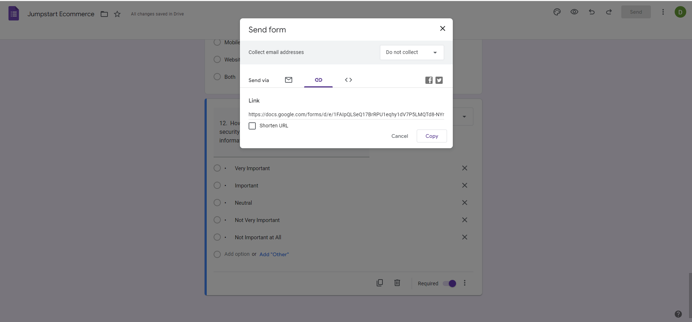

10 Responded

1. **Collect and analyze results**: this would be in the form of Graphs (pie charts or bar graphs)

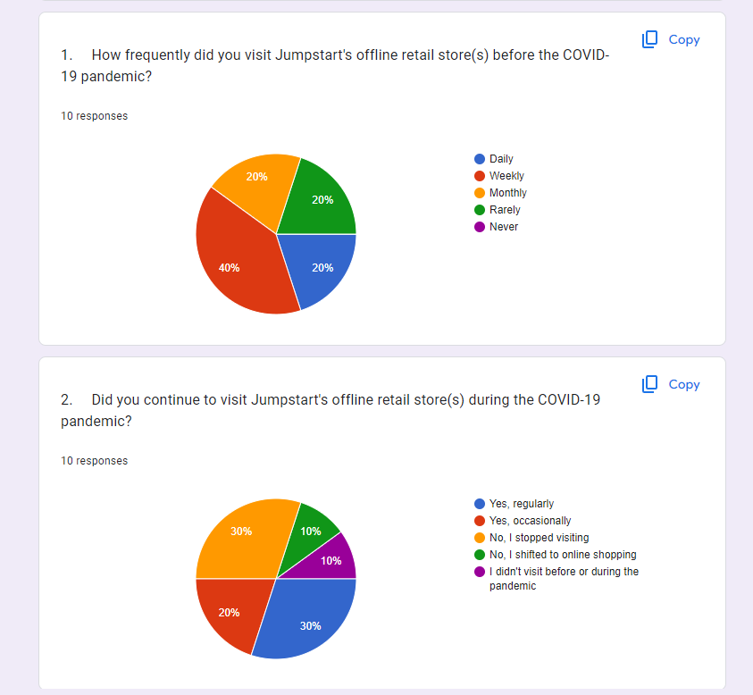

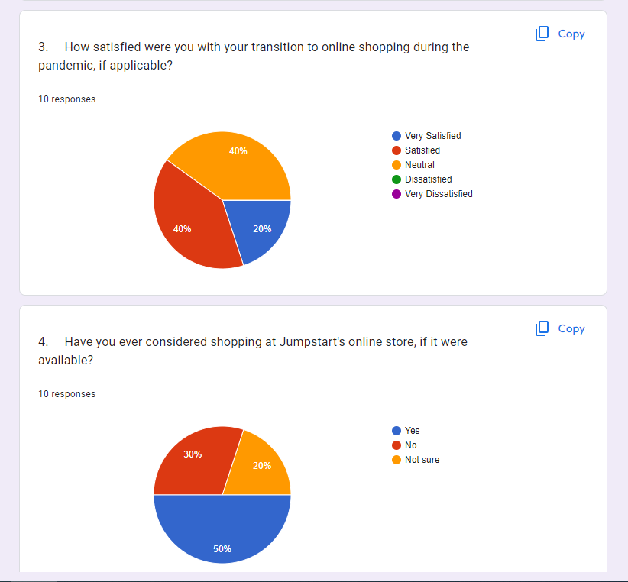

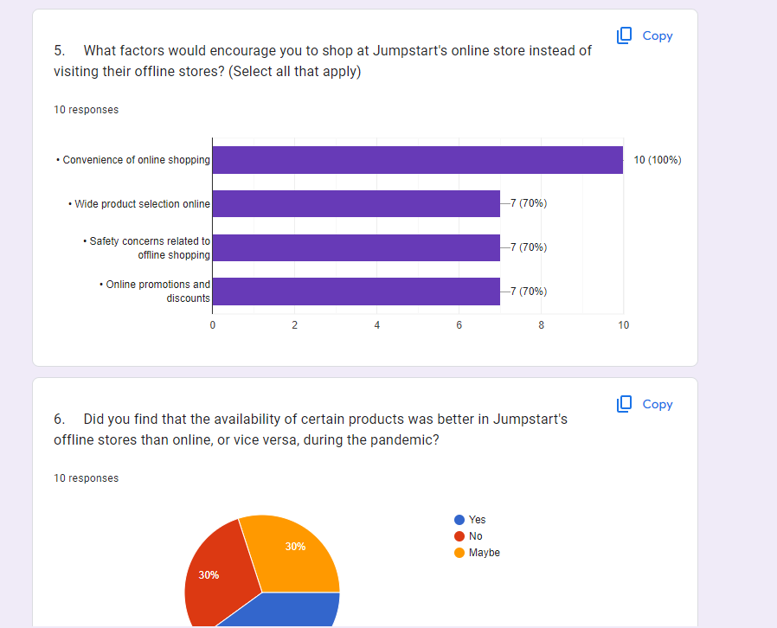

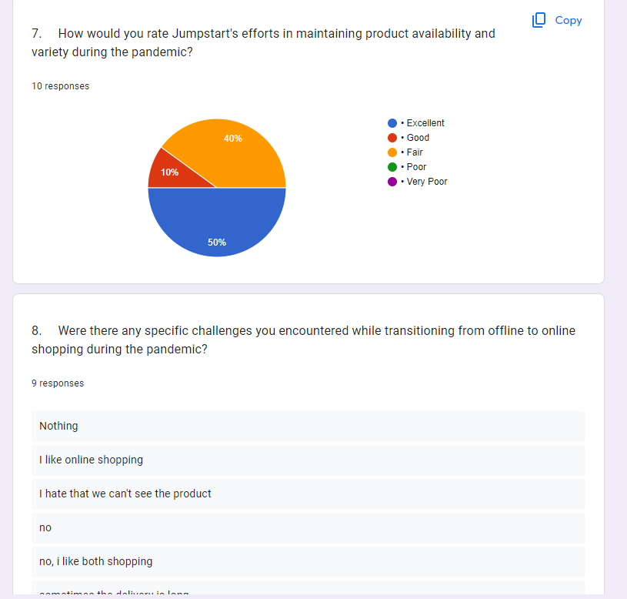

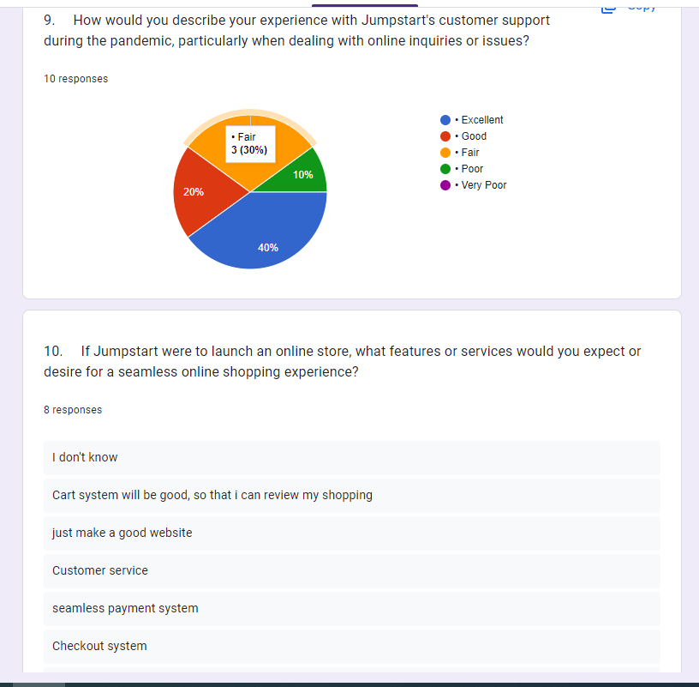

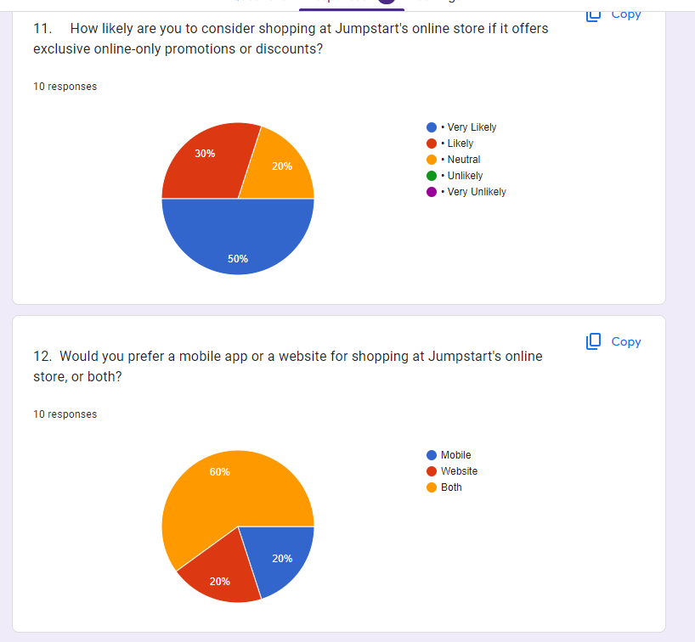

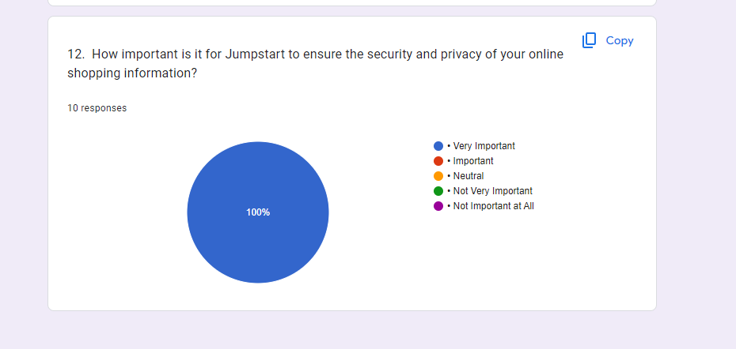

*** Conclusion: Most of the responses have no problem with online shopping and would rather go online shopping due to the convenience, Some of the responses says that they stop going to physical store due to the pandemic and Now it is the best time to do Online shopping therefore making an digitalization to an E-commerce business model is very important in this current stage

* 1. Conduct Secondary research (Identify Tools and techniques):
* Digital transformation:

Digital transformation in the context of retail businesses like Jumpstart involves leveraging technology to enhance various aspects of operations and customer engagement. The scope of digitalization in the retail industry is extensive and can bring numerous benefits

* Scope of digitalization in Retail business: what benefits DX can bring in various areas of industry?
* Improved Customer Experience: DX allows retailers to provide personalized shopping experiences, efficient customer service, and convenient online and offline shopping options.
* Enhanced Operational Efficiency: Automation and data analytics can optimize inventory management, supply chain operations, and employee productivity.
* Data-Driven Insights: Retailers can gain valuable insights into customer behavior, preferences, and trends through data analysis, enabling better decision-making.
* Multichannel Presence: DX enables retailers to establish a strong online presence, reaching customers through e-commerce, social media, mobile apps, and physical stores.
* Cost Reduction: Automation and streamlined processes can reduce operational costs, while targeted marketing can optimize ad spend.
* Example of DX: refer case studies:

Amazon: Amazon's use of advanced data analytics and logistics optimization has revolutionized e-commerce. Their emphasis on customer-centricity through data-driven personalization has led to significant growth.

Walmart: Walmart has embraced DX through initiatives like Walmart+, offering a subscription-based service with various benefits, and investments in e-commerce to compete with online giants.

* **DX scope for Jumpstart: which digitalization's are possible for jumpstart:**
* New Business Models: Explore online sales and potentially introduce an e-commerce platform to reach a broader audience.
* Reduce Costs and Increase Revenue: Optimize pricing strategies and supply chain management to reduce costs while expanding the customer base through digital channels to increase revenue.
* Customer Experience: Invest in user-friendly interfaces, mobile apps, and responsive customer support to enhance the overall customer experience.
* Operational Efficiency: Streamline inventory control and logistics through automation and real-time data analytics to improve operational efficiency.
* Conversion and Loyalty: Implement data-driven insights to improve customer conversion rates and foster customer loyalty.

Consider costs, access and ethical issues.

|  |  |
| --- | --- |
| **LR/Case study_Considerations** | **Description** |
| Cost | Conducting a literature review typically has minimal direct costs. However, there may be expenses related to accessing academic databases or purchasing relevant research papers. Additionally, if external help or specialized software is required for data analysis, these costs should be considered. |
| Access | Access to academic databases, scholarly journals, and research papers is essential for conducting a comprehensive literature review. Ensuring access to the necessary resources and databases is crucial for gathering relevant information. |
| Ethical | Ethical considerations in a literature review involve ensuring that the research adheres to ethical standards. This includes proper citation of sources to avoid plagiarism, respecting copyright laws, and maintaining the integrity of the research process by accurately representing the work of other researchers. |

(a) Content analysis

|  |  |  |  |
| --- | --- | --- | --- |
| No. | Title | Reference Link | Outcomes |
| 1 | The change in e-commerce in the context of the Coronavirus pandemic | https://www.researchgate.net/publication/361938564_The_change_in_e-commerce_in_the_context_of_the_Coronavirus_pandemic | The document delves into the utilization of e-commerce and online shopping across various nations, shedding light on shifts in online activities during the COVID-19 pandemic. It notes that the Netherlands and Finland exhibit the highest proportions of individuals engaged in online selling, while Denmark and Sweden boast the highest percentages of people making online purchases. Belgium and Ireland emerge as leaders in terms of enterprises' turnover attributed to e-commerce. |
| 2 | The Impact of COVID-19 Pandemic on E-commerce | https://www.atlantis-press.com/proceedings/ssha-22/125972411 | Covid19 had a positive impact on the e-commerce industry, with the online shopping division experiencing the greatest impact. The overall impact of the pandemic on e-commerce was positive, and there is potential for further innovation in this area. Increasing demand for online shopping. |
| 3 | E-commerce trends during COVID-19 Pandemic | https://www.researchgate.net/publication/342736799_E-commerce_trends_during_COVID-19_Pandemic | The document discusses the impact of the COVID-19 pandemic on e-commerce trends. It highlights how the pandemic has changed consumer behavior, increased the growth of e-commerce, and affected economies worldwide. Specific examples are given, such as the increase in online shopping and the rise of e-commerce in developing countries like Pakistan. The document also mentions the need for further research in this area. |

(b) Trend analysis

Attach some graphical evidence: u can present some analysis records collected on different retail business progress, their impact_status during pre-covid and post covid and use of Digitalization in the Business during the pandemic.

* 1. Graph on how various retail industries impacted during the covid: few analysis

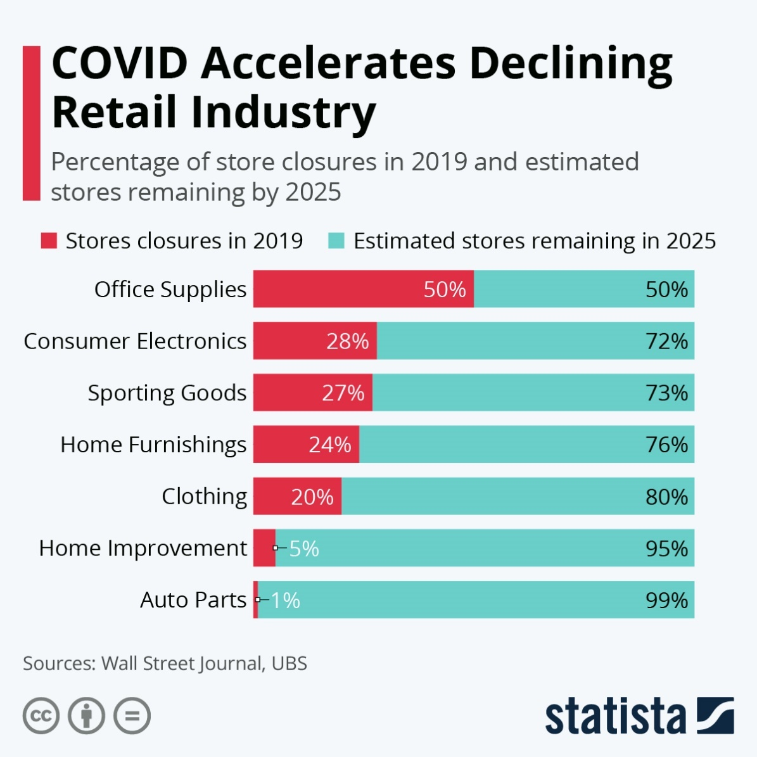

* 1. Graph on Remote Working impact on retail market

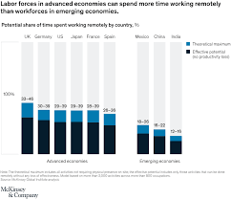

* 1. Graph on how DX play vital role in help the industry in its growth

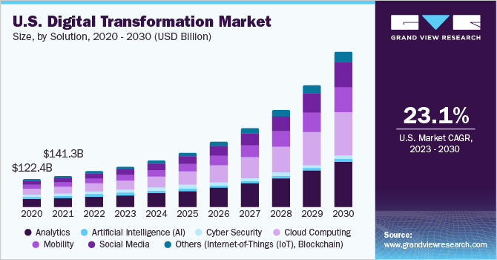

**** Conclusion:

In light of the extensive research conducted on the digital transformation (DX) possibilities for Jumpstart, it is evident that the proposed solution aligns seamlessly with Jumpstart's multifaceted requirements. Jumpstart, under the leadership of Senior Manager Mr. Martin, has articulated a set of strategic objectives aimed at enhancing various aspects of its retail business. These objectives span from redefining business models to elevating customer experience, from optimizing operational efficiency to driving cost reduction while simultaneously increasing revenue. The proposed DX solution comprehensively addresses these requirements.

Reference Link:

Secondary Research Analysis (Document based):

Literature Review Process: stepwise highlight

<https://www.google.com/search?q=literature+review+process&rlz=1C1GGRV_enIN753IN753&sxsrf=ALeKk01BhMT_-Ll4jhTKHGQK2Npuq0OCsA:1621578730255&tbm=isch&source=iu&ictx=1&fir=KMXfKqPuOctsyM%252CFEikhVlHQQCpiM%252C_&vet=1&usg=AI4_-kSi-V5iDySfOUnGHgVQUg5fSEG7Lg&sa=X&ved=2ahUKEwjaqMTBk9rwAhWSXSsKHVqxCGIQ_h16BAgMEAE#imgrc=RxUPngqrpHrnWM>

<https://www.questionpro.com/blog/secondary-research/>

<https://www.questionpro.com/blog/secondary-research/#:~:text=Secondary%20research%20or%20desk%20research,involves%20using%20already%20existing%20data.&text=Secondary%20research%20includes%20research%20material,already%20filled%20in%20surveys%20etc>.

<https://www.oxbridgeessays.com/blog/how-to-dissertation-secondary-research-4-steps/>

<https://www.statista.com/topics/6239/coronavirus-impact-on-the-retail-industry-worldwide/#dossierContents__outerWrapper>

Data analysis(qualitative): Trend Analysis, content analysis+secondary Research use with example +sources of information+checkList for a critical Literature Review + references in the bibliography)

Analytical techniques: Content and Trend Analysis [how Literature Review got conducted and helped in collecting what data/information? + Data Sets]

<https://www.scribbr.com/methodology/content-analysis/>

<https://www.scribbr.com/category/methodology/>

**Project Part (Part II)**

1. Project Proposal
2. Project Objective

E-commerce functionality is a pivotal component of any online retail venture, and Jumpstart is certainly no exception. As a project manager at Aceadora Tech, undertaking research on e-commerce for Jumpstart can assist you in pinpointing top-notch practices and approaches to enhance their online retail processes.

1. Scope

The scope of this project includes researching and proposing a new E-Commerce system for Jumpstart. The proposed system will cover the following areas:

* Product addition
* Cart system
* Checkout System
* Automated Payment getaway
* Provide order history
* User and order data management

1. Constraints

Limited Data Accessibility:

Gaining access to pertinent data regarding Jumpstart's E-commerce operations might be restricted, posing challenges in acquiring an all-encompassing comprehension of the company's functioning.

Time and Resource Constraints:

Conducting comprehensive E-commerce research may necessitate substantial time and resource allocation, which might be constrained by other project obligations or organizational commitments.

Financial Limitations:

Thorough research in the realm of E-commerce might involve notable financial investments, encompassing data access and specialized software utilization. These investments could be subject to constraints posed by budgetary limitations.

Technical Proficiency:

Undertaking E-commerce research may call for technical proficiency, encompassing expertise in specialized software, statistical analysis, and proficient data management. These requisites could be limited by the skill set and expertise of the research team.

Organizational Boundaries:

The research may encounter constraints tied to organizational protocols, procedures, or priorities, potentially delimiting the research's scope or direction.

1. Assumptions

* The product information provided by Jumpstart is accurate and consistently updated.
* The current E-commerce platform used by Jumpstart is not fully optimized for seamless online shopping and checkout experiences.
* The proposed E-commerce enhancements will be technically viable and adaptable to accommodate Jumpstart's existing and future requirements.
* The proposed E-commerce improvements will result in enhanced user experience, streamlined checkout processes, and increased customer satisfaction.
* Jumpstart is willing to allocate the necessary resources and budget for implementing the proposed E-commerce enhancements.
* The proposed E-commerce improvements will not disrupt ongoing business operations or negatively affect the customer journey.
  1. Project Environment (System requirements – hardware, software requirements, User requirements, Project blueprint [flowchart/ wireframes/Axure prototype, storyboard, IA, etc.], application working Process – Business Process

1. System requirements – hardware, software requirements

|  |  |  |  |
| --- | --- | --- | --- |
| **No** | **Hardware** | | |
| **Type** | **Service** | **Client** |
| **1** | Processor | Intel i5 2.6 GHZ | Intel-i3 or above |
| **2** | Memory | 12GB | 4GB or above |
| **3** | Hard Drive | 4TB SSD NVME | 1TB or above |
| **4** | Network | Gigabit Network | Wifi / Internet Providers |

|  |  |  |
| --- | --- | --- |
| **No** | **Software** | |
| **Software Device** | **Functionality** |
| **1** | Window 10 | Operating System |
| **2** | Visual code, eclipse,spring boot | Web Creation |
| **3** | Tomcat | Web server |
| **4** | MySQL | Databases |
| **5** | Figma | Design |
| **6** | Google,Chrome,microsoft edge | Web Browser |

1. Project blueprint

Overall website Sitemap

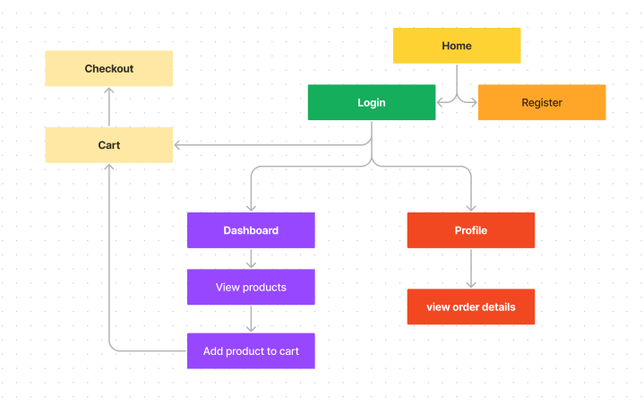

EERD

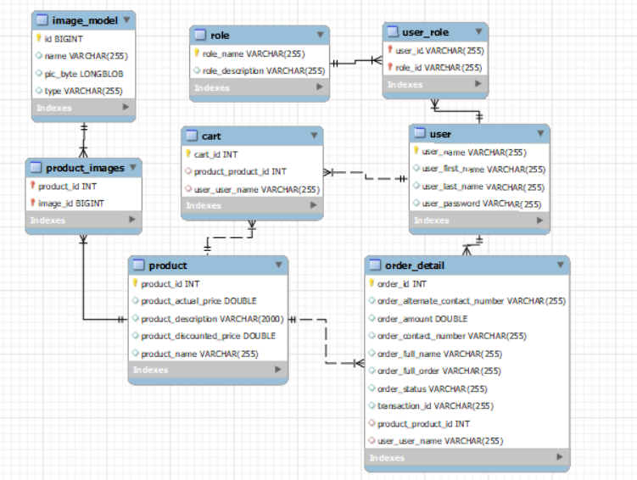

Login flowchart

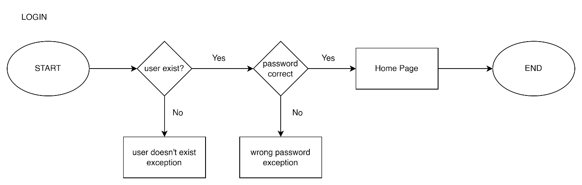

Register flowchart

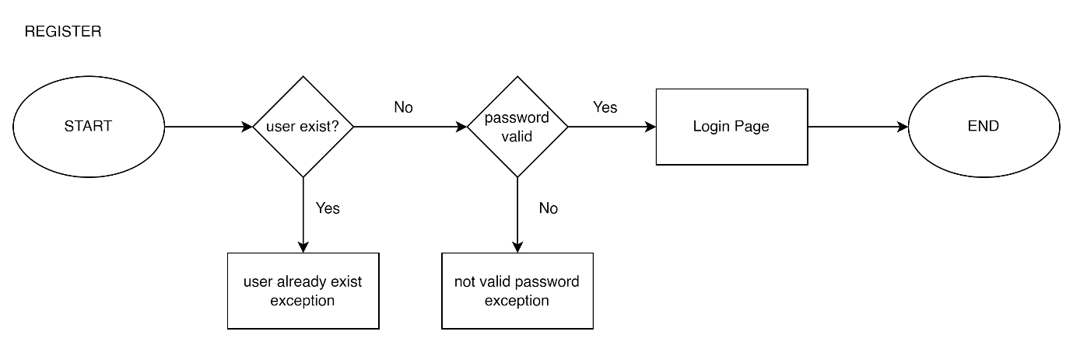

Business process

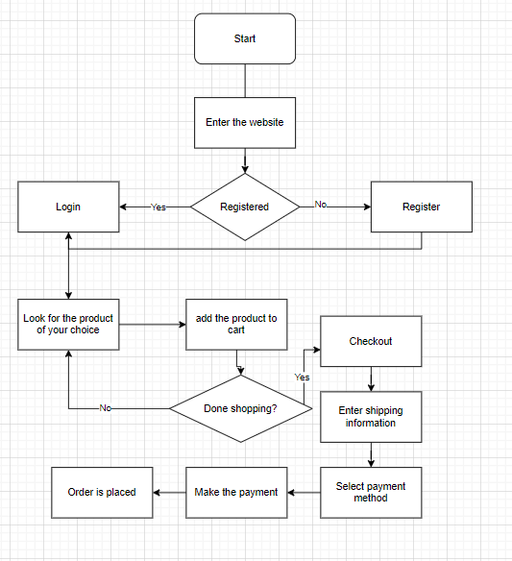

Wireframe

Home page



Register

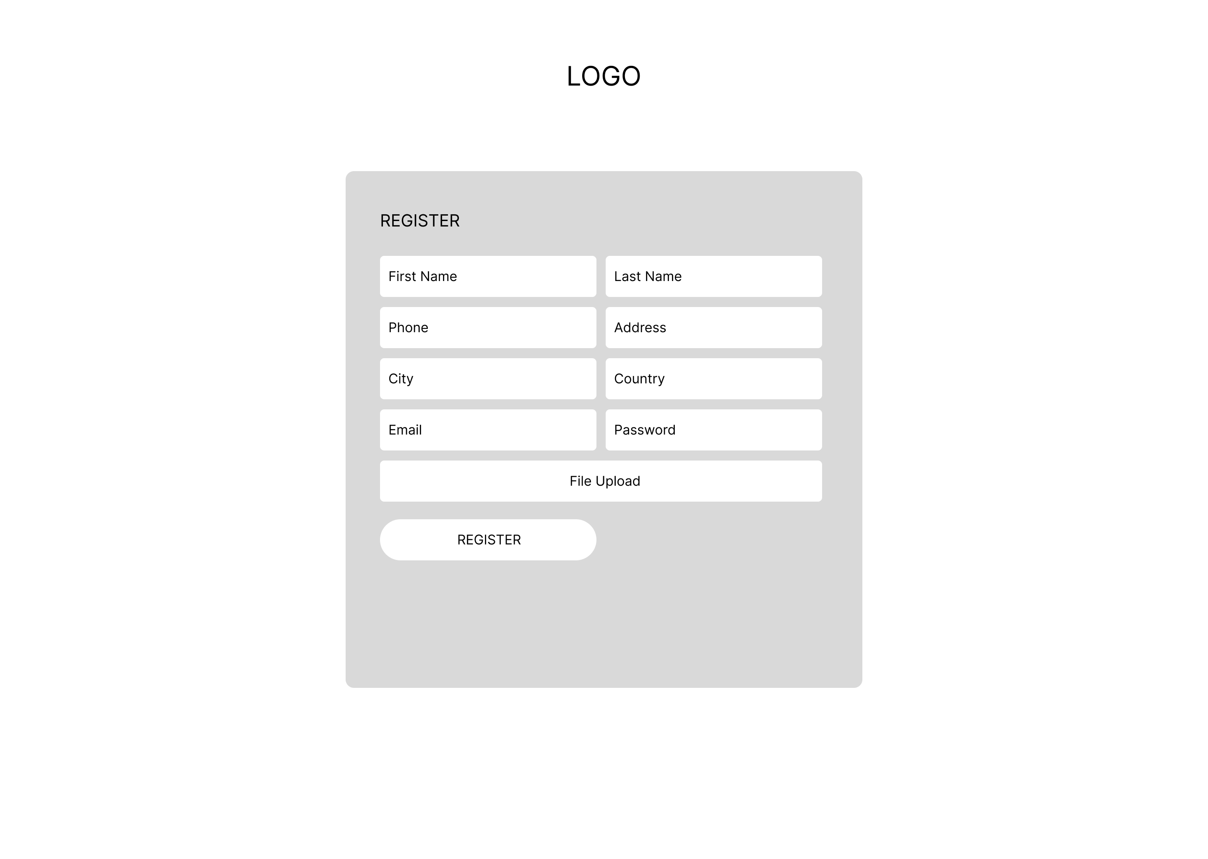

Login

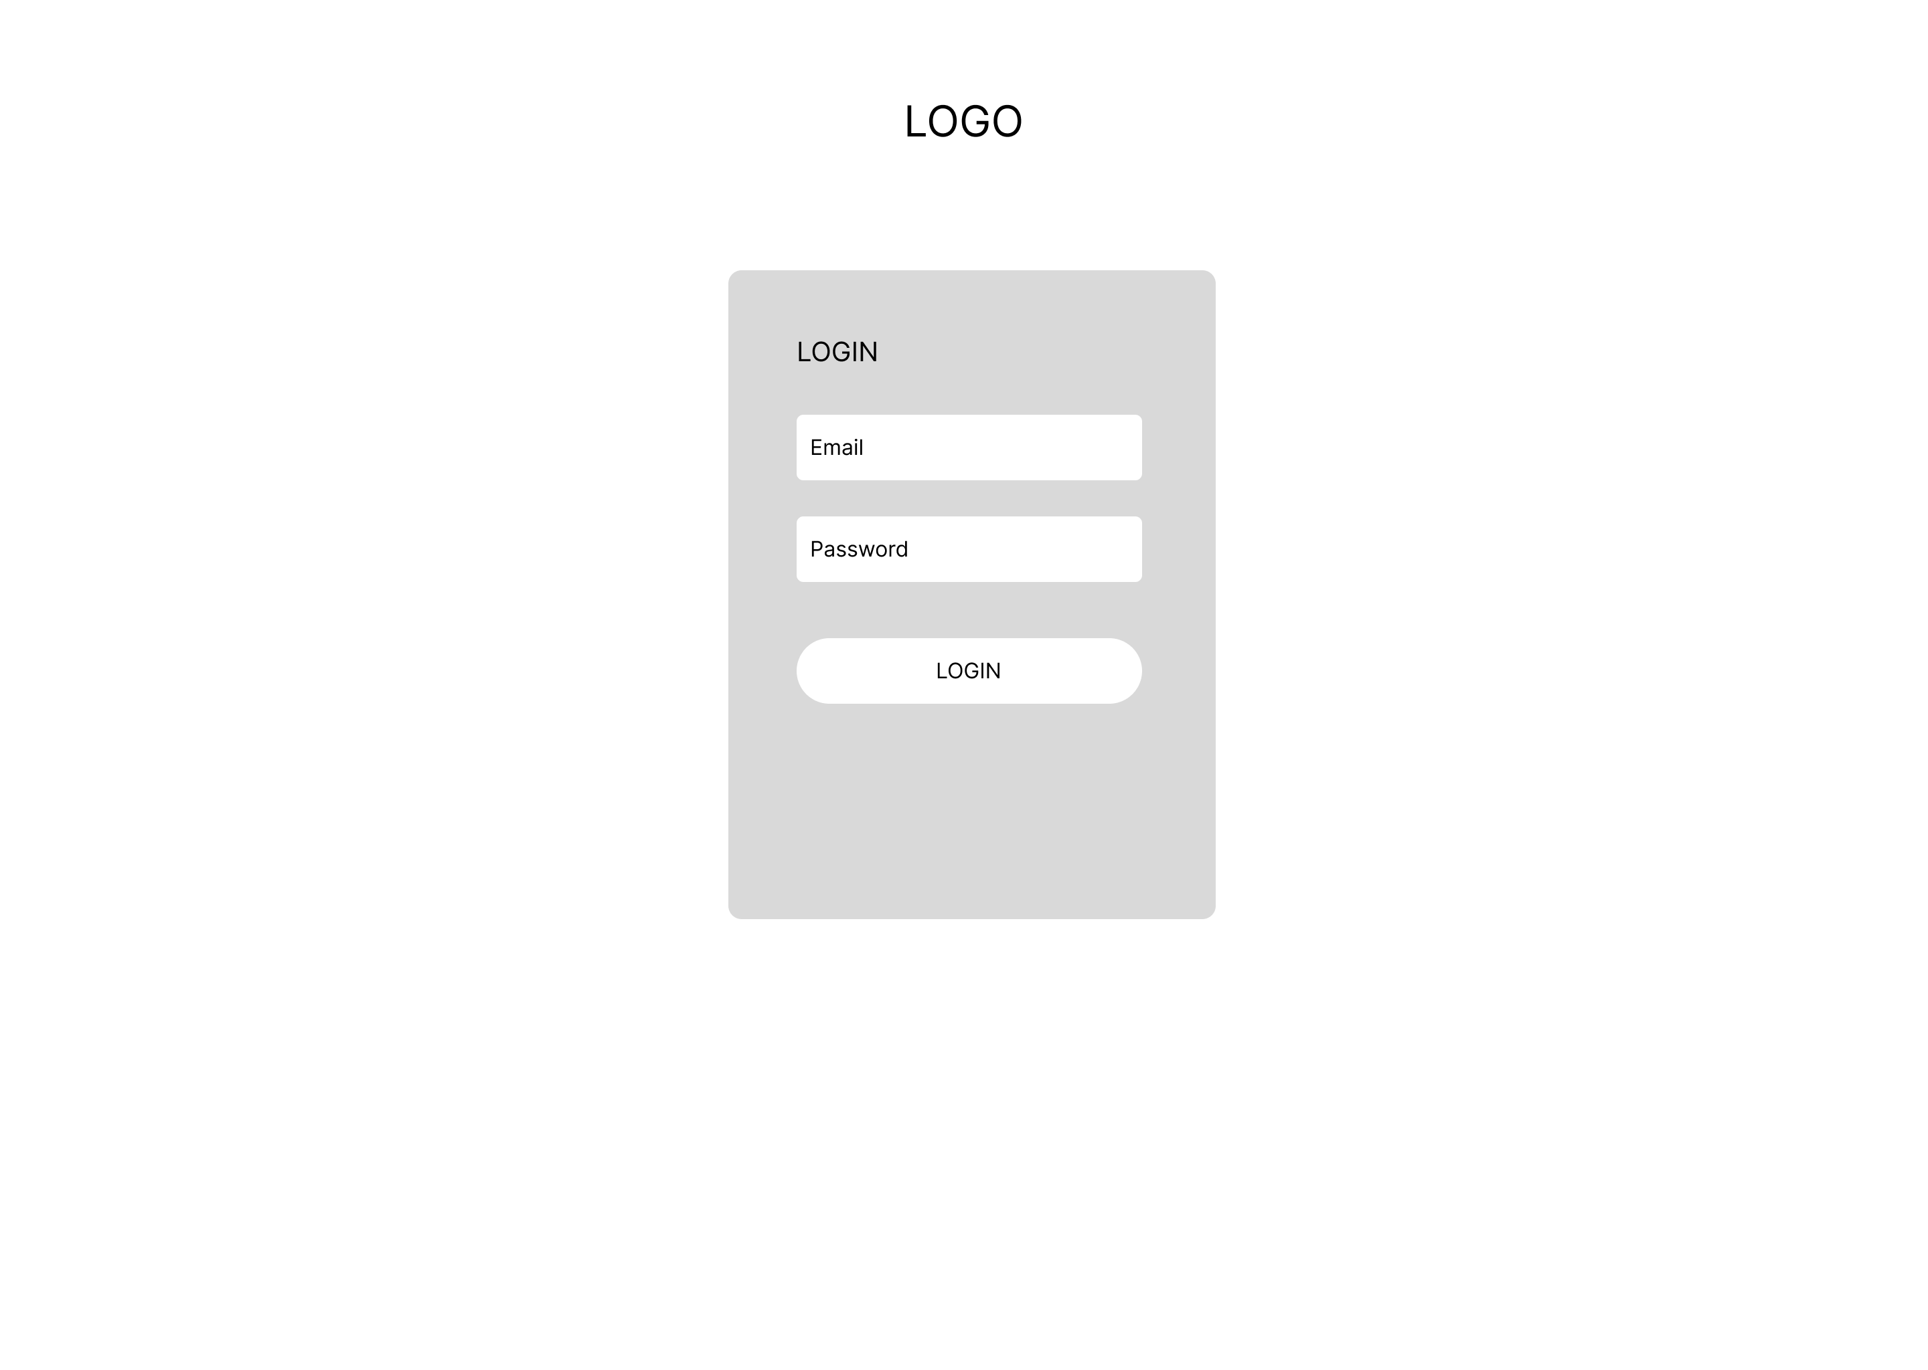

9. Communication with Stakeholders:

* List down who are they in this business case

**Communication Matrix: Plan** out the following:

Who are sender and Receiver?

What is the purpose of communication?

What outcome is going to be achieved?

What is the channel of communication? - Medium

What is the frequency of communication?

|  |  |  |  |  |
| --- | --- | --- | --- | --- |
| Sender | Receiver | Purpose | Medium | Frequency |
| Acedora PM | Jumpstart Emplyee/customer | Communicate to provide the solution & recommendation | Microsoft Teams | once in project Life |
| Acedora PM | Senior Manager of Acedora | Plan project flow | Email, Microsoft Teams | Twice per week |
|  |  |  |  |  |

10. Project Implementation: attach all evidence of implementation

10.1 Source Code and evidence (SS of project results)

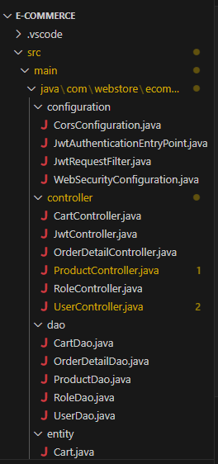 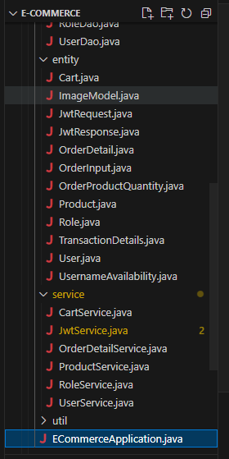

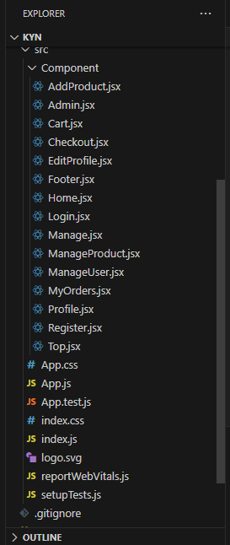  
  
some of the file

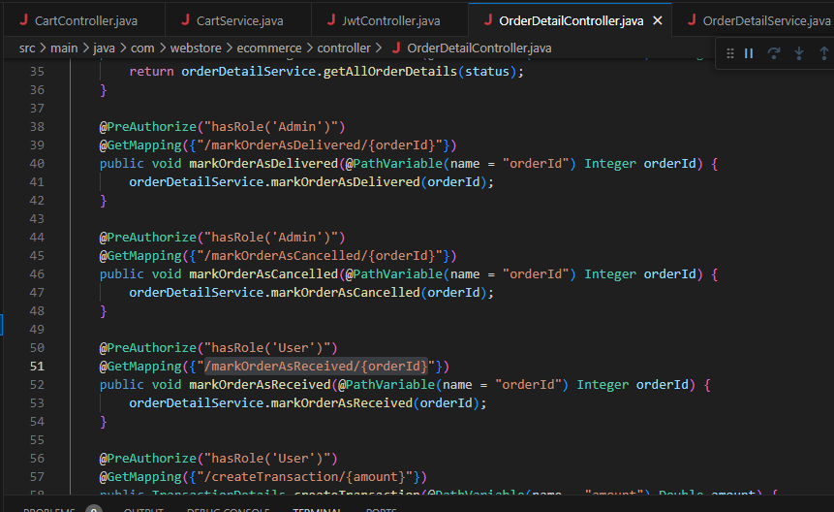

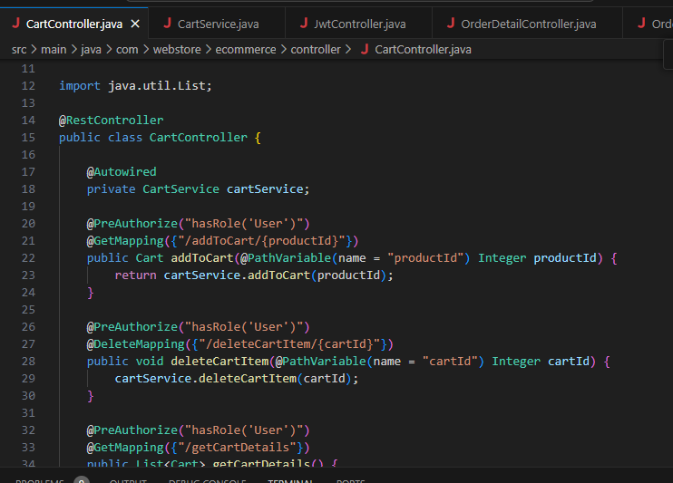

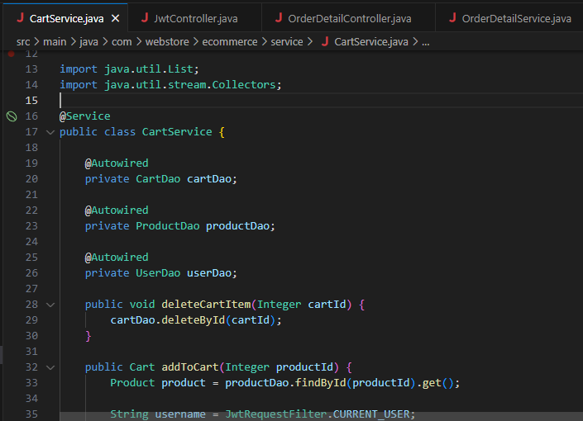

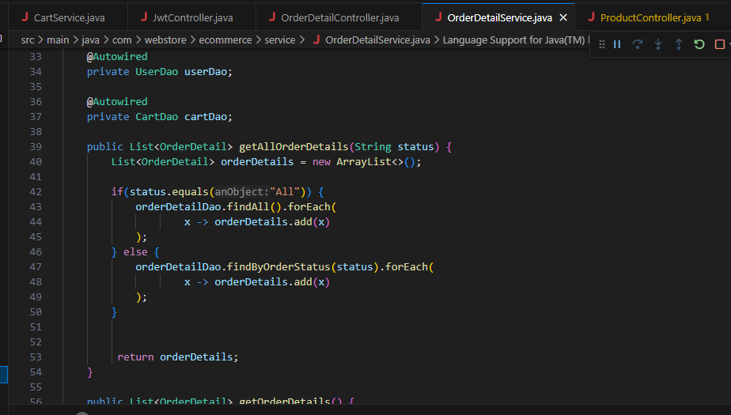  
  
Website ScreenShot  
Home page

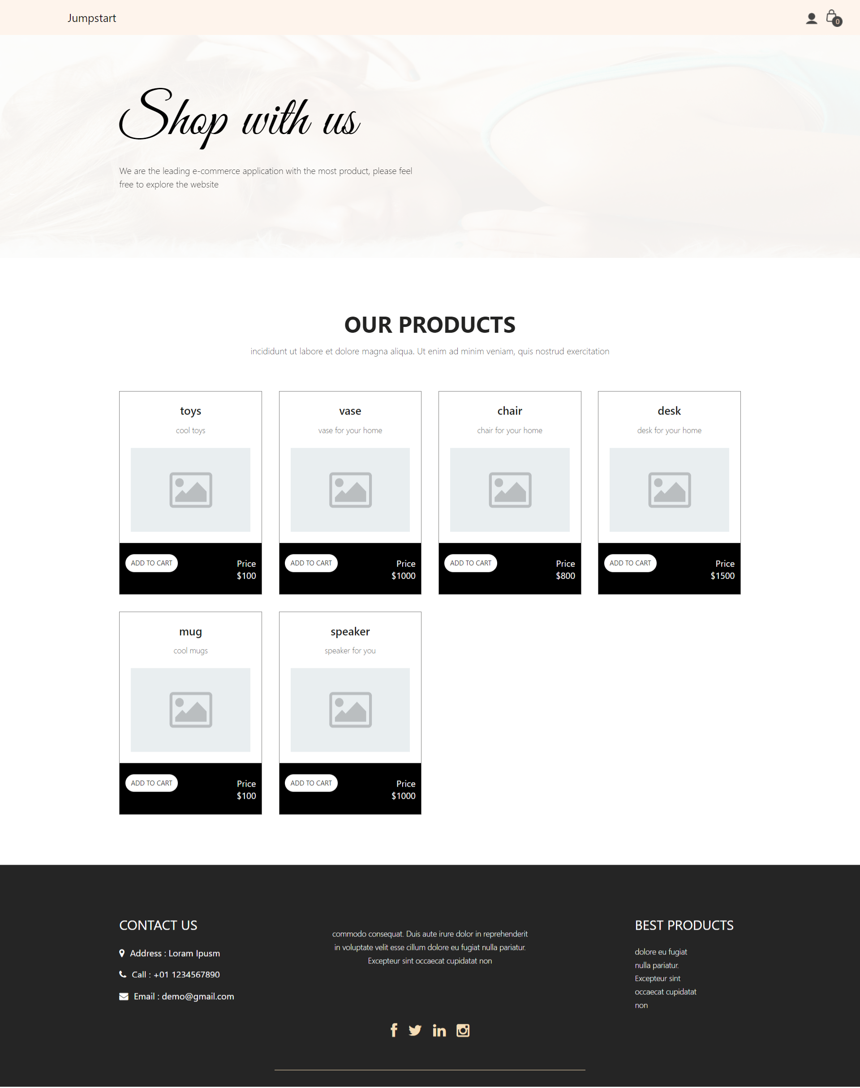

Login page

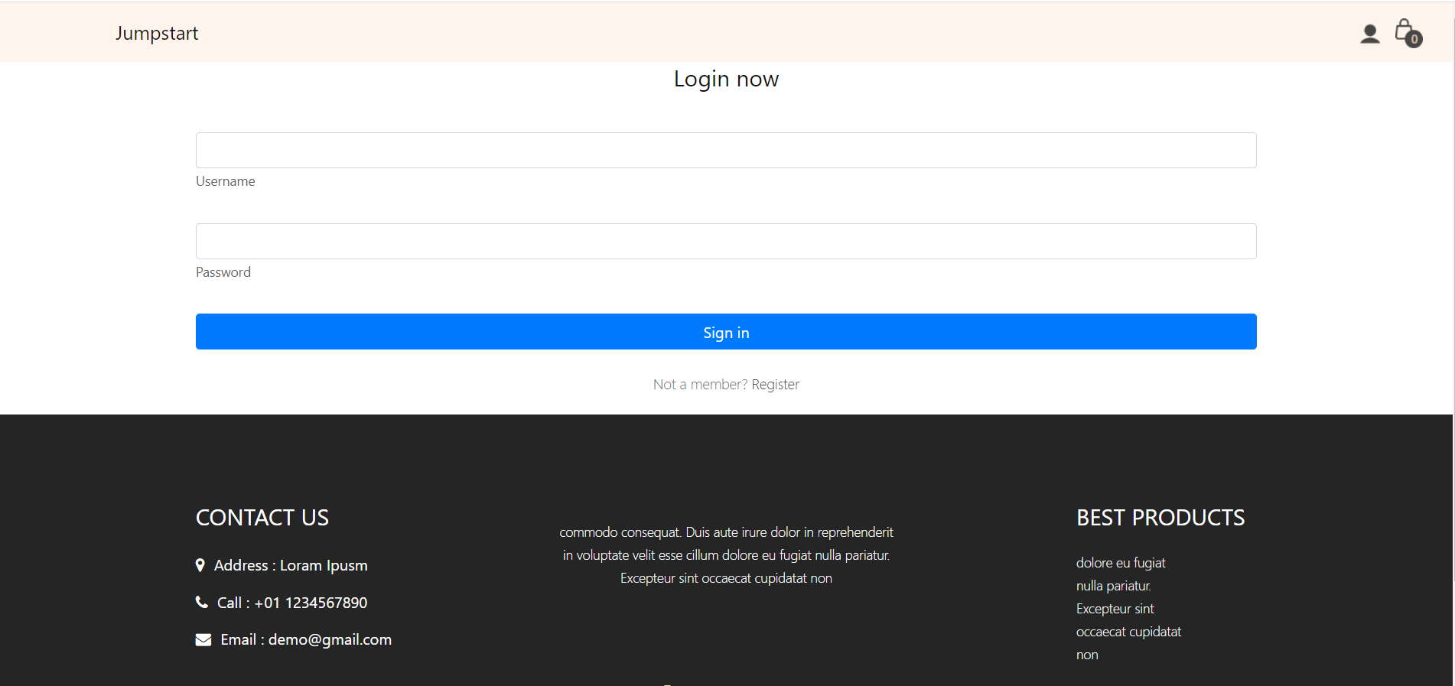

Register page

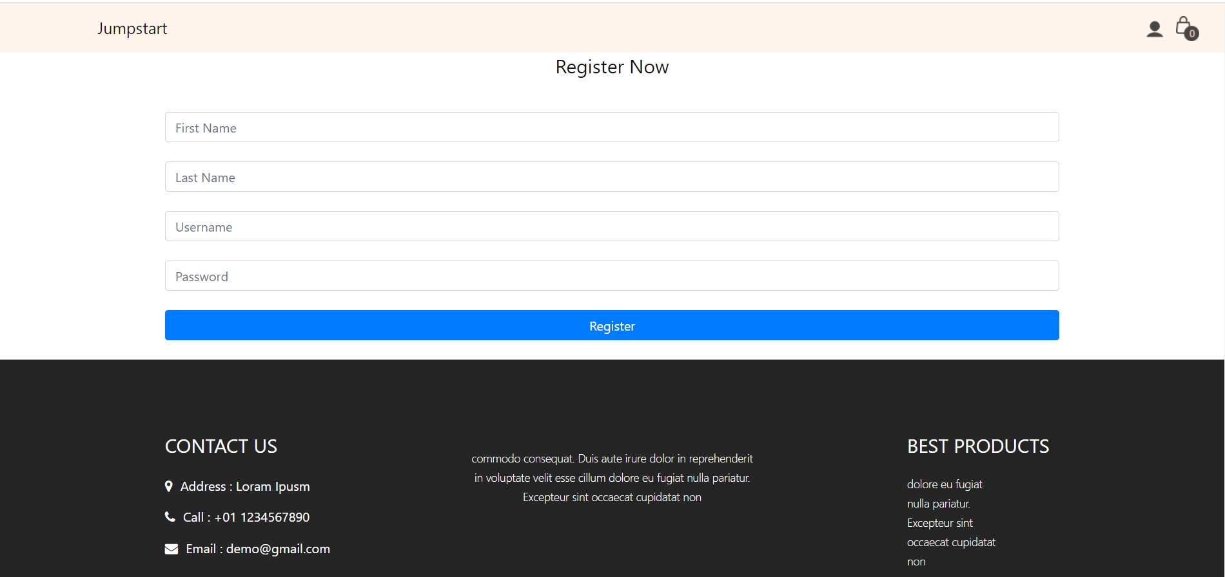

Cart page

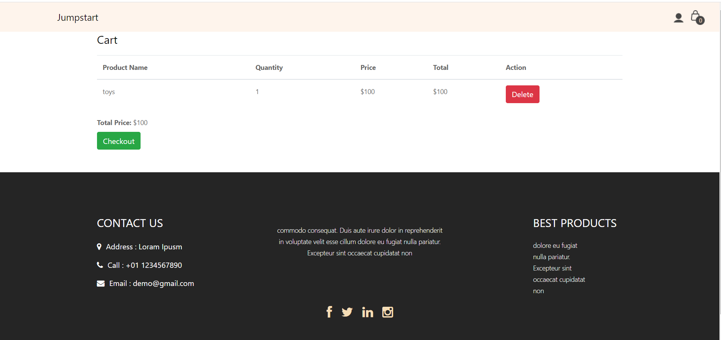

Checkout page

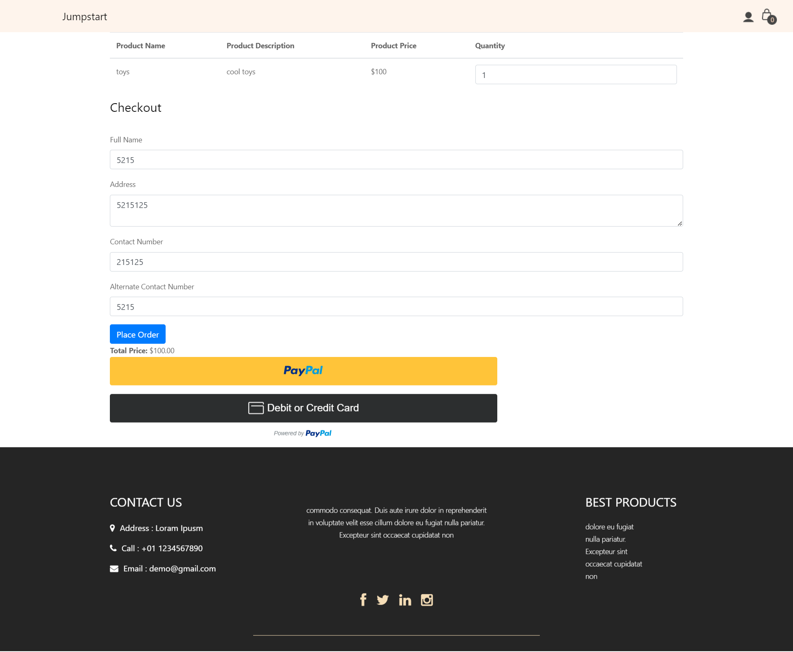

Profile page

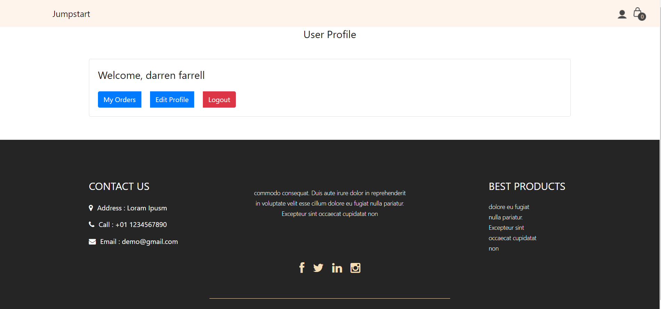

MyOrder page

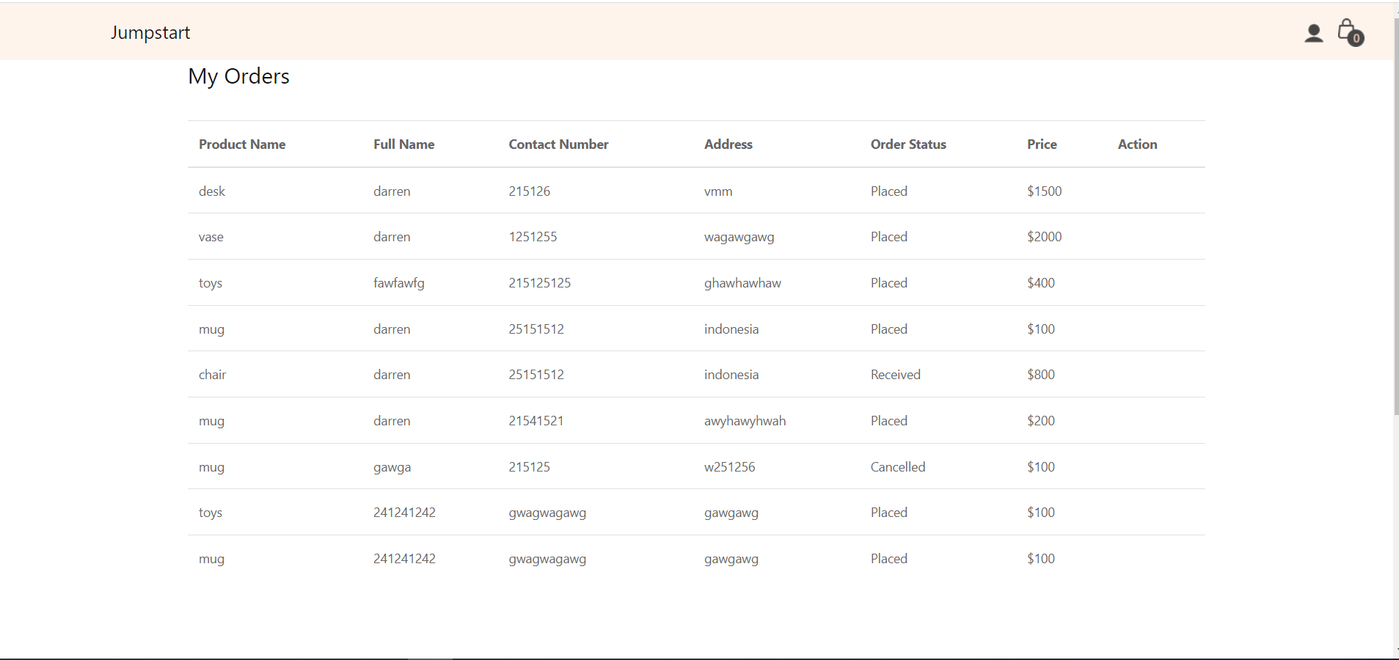

Admin page

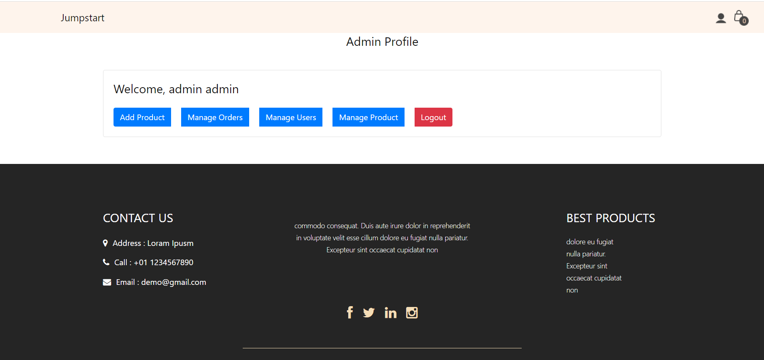

Manage order

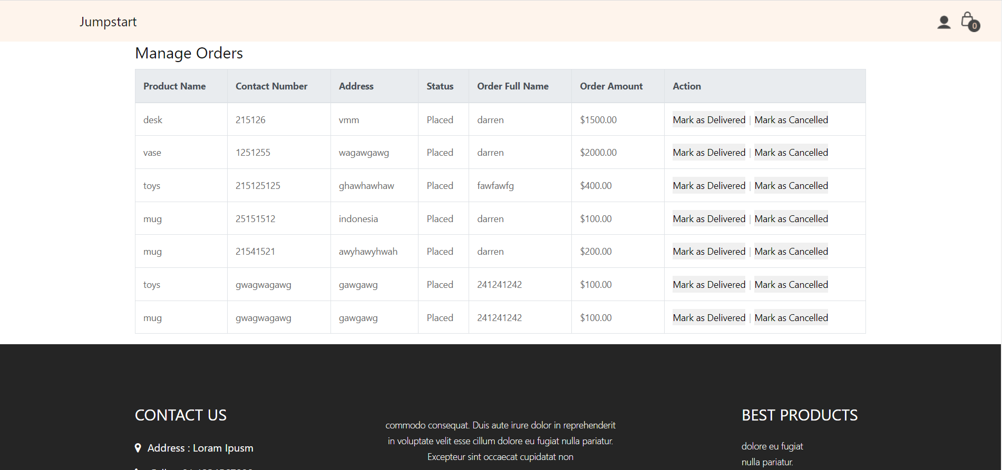

Manage user

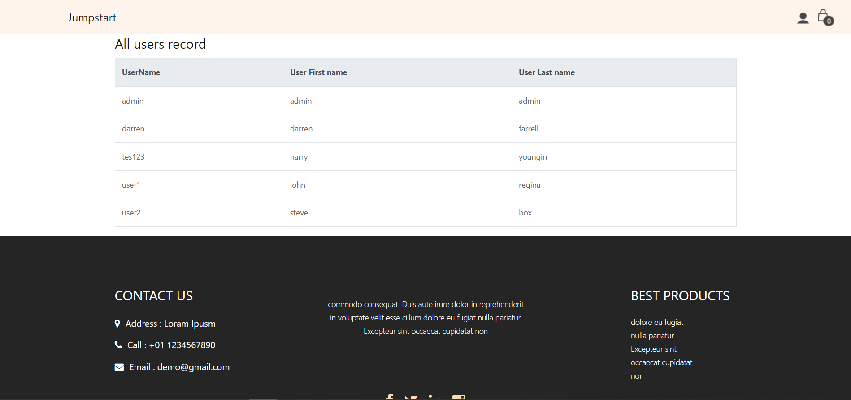

Manage product

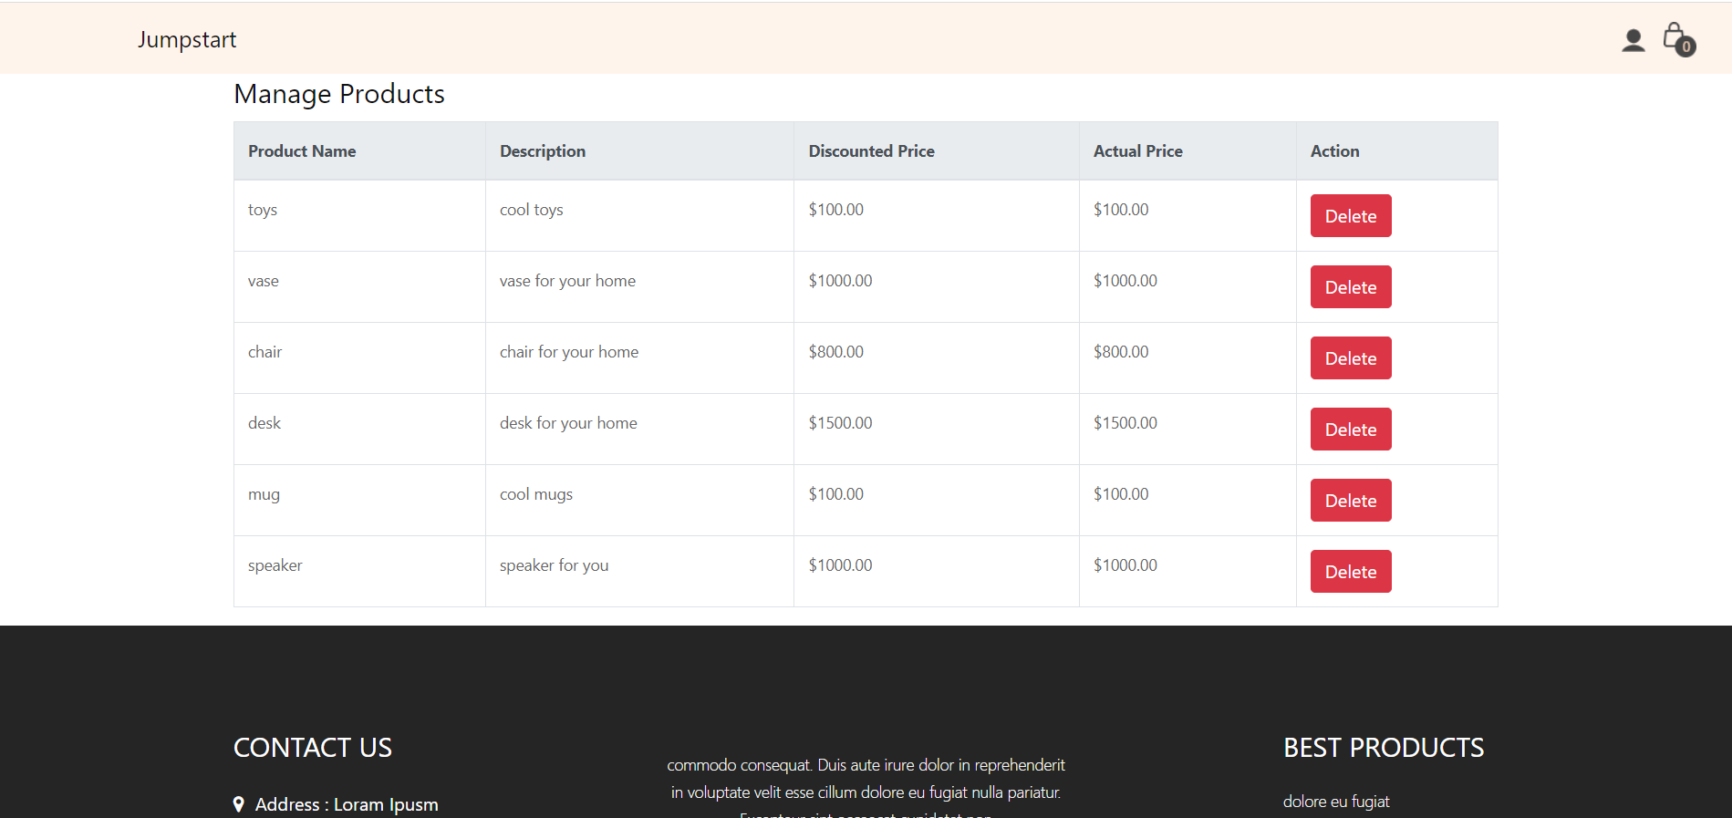

Add product

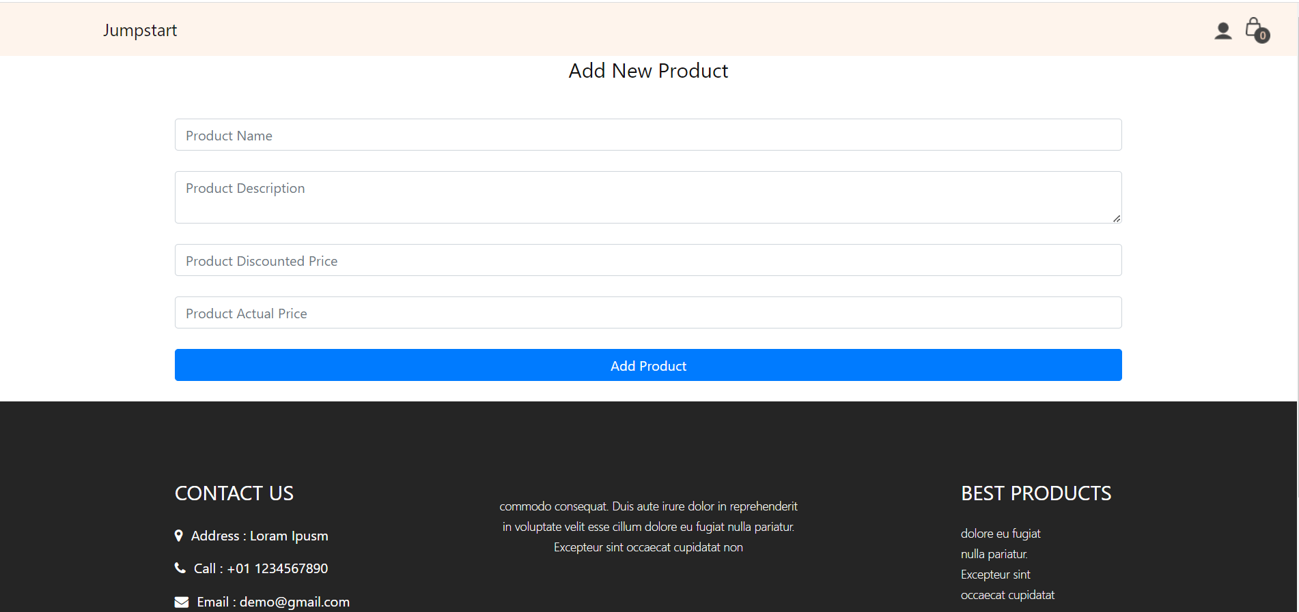

Edit profile

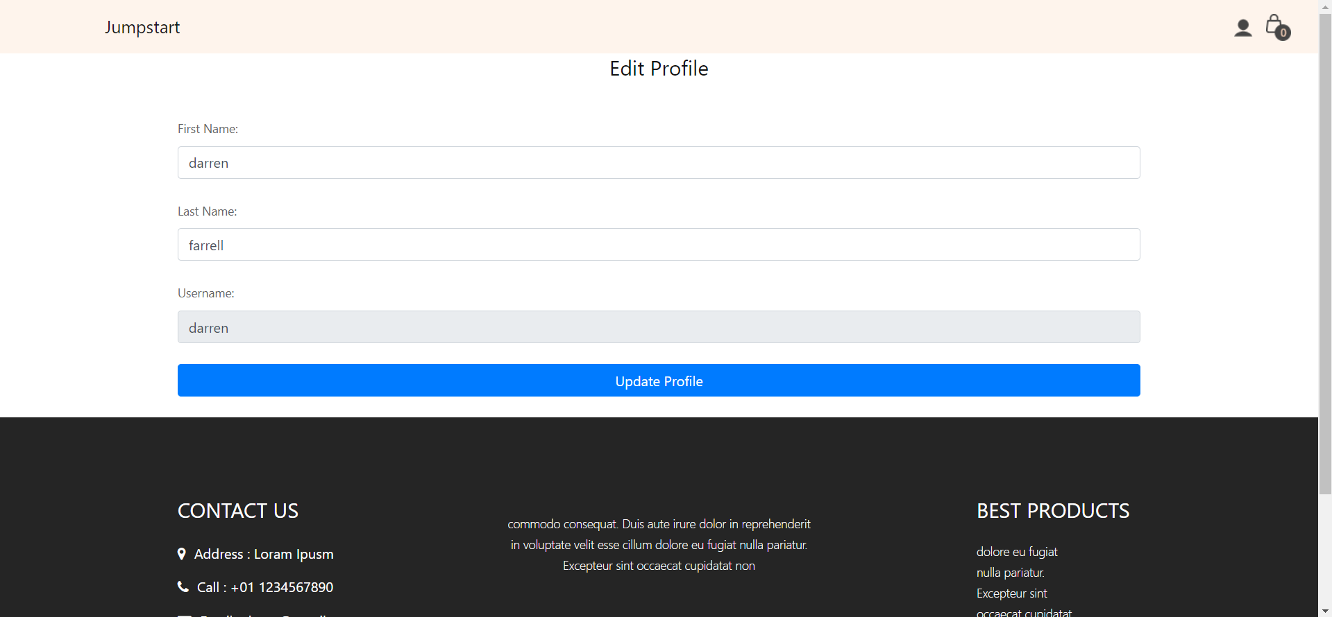

10.2 Post -implementation Survey: survey objective: to understand the pulse of Jumpstart customer/employee about online Shopping system

Survey Frame - 6 to 8 questions

1. How satisfied are you with the overall user experience of Jumpstart's e-commerce website, including navigation, layout, and ease of use?

• Very Satisfied

• Satisfied

• Neutral

• Dissatisfied

• Very Dissatisfied

2. On a scale of 1-5, how easy is it for you to find products you are looking for on Jumpstart's e-commerce website?

• 1 (Very Difficult)

• 2

• 3 (Moderate)

• 4

• 5 (Very Easy)

3. Please rate your experience with the product selection and variety offered on Jumpstart's e-commerce website.

• Excellent

• Good

• Fair

• Poor

• Very Poor

4. How satisfied are you with the functionality and reliability of the shopping cart system on Jumpstart's e-commerce website?

• Very Satisfied

• Satisfied

• Neutral

• Dissatisfied

• Very Dissatisfied

5. Did you encounter any issues during the checkout process on Jumpstart's e-commerce website (e.g., payment errors, page loading problems)?

• Yes

• No

• Maybe

6. On a scale of 1-5, how secure do you feel when making online payments through Jumpstart's e-commerce website?

• 1 (Not Secure)

• 2

• 3 (Moderately Secure)

• 4

• 5 (Very Secure)

7. How satisfied are you with the available payment options (credit card, PayPal, etc.) on Jumpstart's e-commerce website?

• Very Satisfied

• Satisfied

• Neutral

• Dissatisfied

• Very Dissatisfied

8. How likely are you to recommend Jumpstart's e-commerce website to others based on your experiences?

• Very Likely

• Likely

• Neutral

• Unlikely

• Very Unlikely

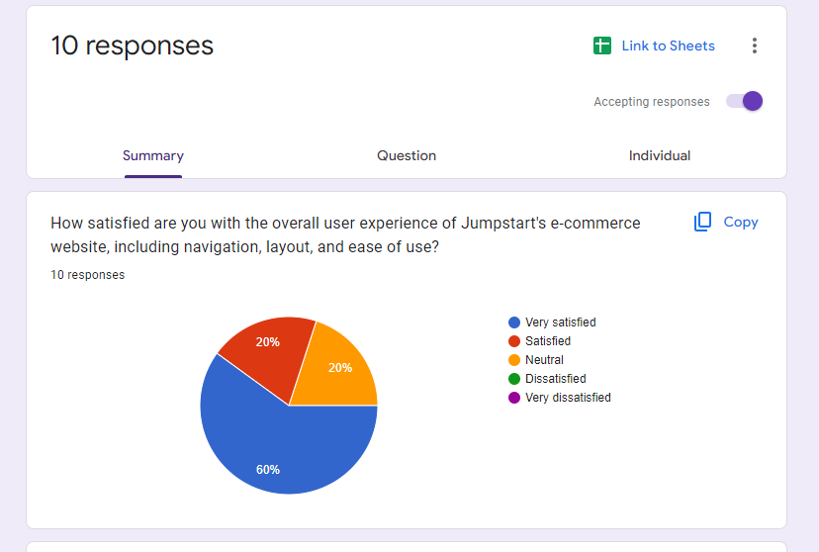

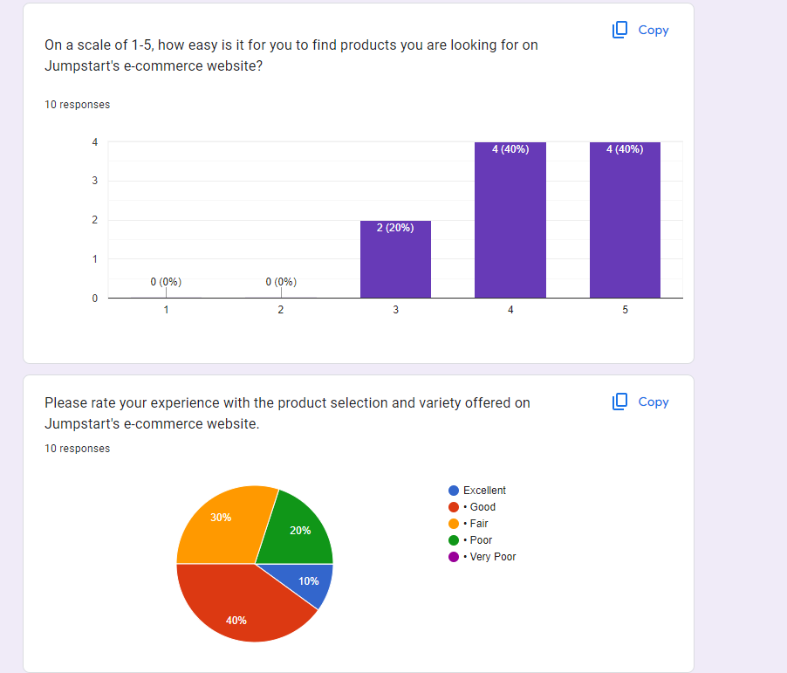

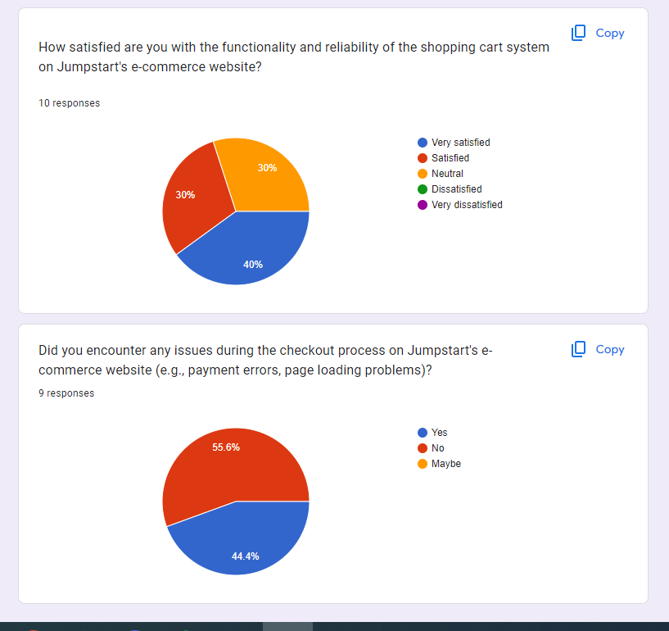

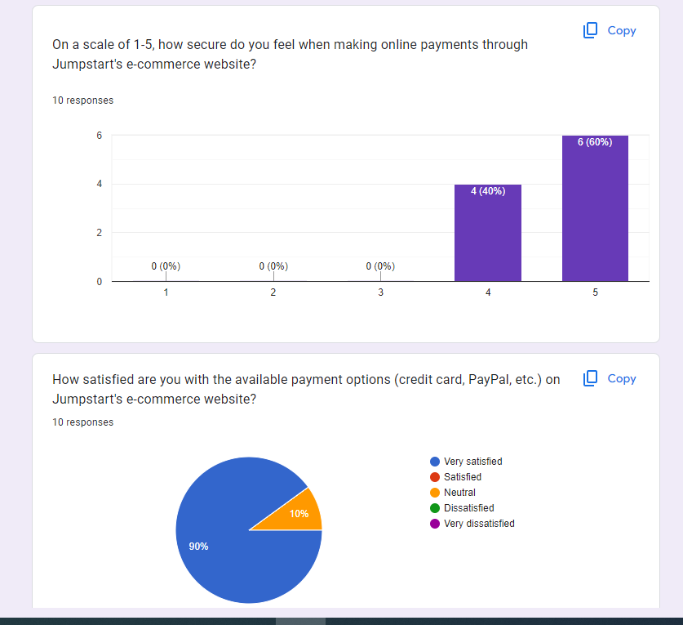

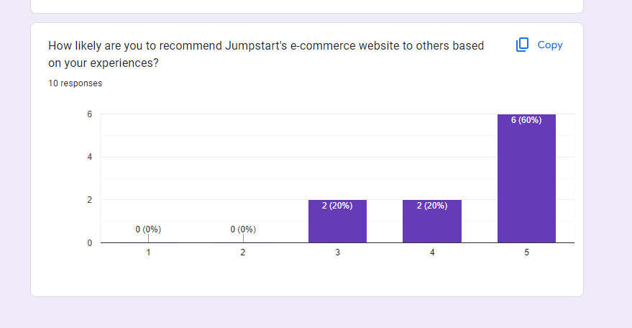

**Conclusion: The jumpstart Ecommerce website is being liked by the people there, they like the payment option, cart system and they feel very secure when using the website**

11. Reflection on Research Methods

11.1 Effectiveness and challenges of methods applied

(a) Survey:

* + - * Effectiveness: Surveys have proven to be highly effective in achieving the CRP (Customer Relationship Platform) objectives. They provided a structured and quantitative approach to gather valuable insights from customers, enabling a data-driven understanding of their preferences and expectations. Surveys efficiently collected information on various aspects such as satisfaction, preferences, and feedback.
      * Challenges: While surveys were effective, they came with some challenges. Respondent fatigue was one issue, as participants might be inundated with survey requests from various sources. Designing concise yet comprehensive surveys to maintain participant engagement was a challenge. Additionally, there was a potential for bias in self-reported data.

(b) LR/case study:

* + - * Effectiveness: The literature review (LR) and case study methods played a pivotal role in achieving CRP objectives. They provided an in-depth understanding of industry trends, best practices, and successful case examples. LR, in particular, allowed for the synthesis of existing knowledge, highlighting the importance of digital transformation in the retail sector.
      * Challenges: Challenges in LR and case study included the vast amount of literature available, making it critical to identify and select the most relevant sources. Additionally, case studies were limited by the availability of comprehensive and up-to-date cases specific to Jumpstart.

11.2 Alternative methods to overcome the challenges:

Interview Beats Survey:

Interviews can overcome the challenges associated with surveys by offering a more interactive and qualitative approach. Interviews allow for probing questions, clarifications, and a deeper exploration of customer insights. They can address respondent fatigue by engaging participants in a conversation rather than a structured questionnaire. However, surveys still hold value for their ability to efficiently collect large-scale data.

Alternative Techniques for LR/Case Study:

An alternative technique for LR could be a meta-analysis, which quantitatively synthesizes findings from multiple studies, providing more robust insights. For case studies, comparative case analysis could be considered, where multiple cases are compared to identify patterns and unique factors contributing to success.

12. Conclusion: n conclusion, the CRP objectives have been successfully achieved through a combination of research methods. Surveys were effective in quantitatively measuring customer preferences and satisfaction, while LR and case studies provided valuable insights into industry trends and best practices. Interviews can complement surveys by offering a qualitative perspective. While challenges existed, they were mitigated through careful design and consideration of alternative methods.

12.1: future research considerations:

Future research should focus on the implementation of digital transformation strategies identified through this research. Additionally, exploring the impact of emerging technologies like AI and blockchain in the retail sector could be a valuable avenue for further investigation. Understanding the evolving landscape of customer preferences and behaviors in the post-pandemic era should also be a key consideration for future research.

14. **Appendix**: rest evidence attaches here [both survey templates SS /observation and witness records, ***Research Proposal Template***

